<https://i.mj.run/3166144f-3390-49f8-a98d-3614c69837ed/0_1.png> pixar style cute mystical baby Harry Potter, realistic, dramatic lighting, 8k, portrait, fine details, photorealism, cinematic ,intricate details, cinematic lighting, photo realistic 8k --creative --testp --upbeta --upbeta --upbeta --upbeta --upbeta --upbeta --upbeta --upbeta



happy dog splashy dog, happy golden retriever dog splashing in the water of a river, water splashing everywhere, trees and redwoods, bright autumn sunlight, smooth rock shore, photorealism --ar 3:2 --testp --upbeta



<https://i.mj.run/87a21929-589b-4d72-97ae-9070b347a458/0_0.png> Sansa as a white horse, Victorian era, mark ryden style art, ornate, highly intricate, detailed photograpy, photorealistic, dark fantasy, detailed and complex, highly detailed, intricate, vivid color, ultra-realistic, intricate detail, highly detailed, ultra detail, hyper detail, 8k, unreal engine, HDR, cinematic lighting, ray tracing --ar 2:3 --test --creative --upbeta

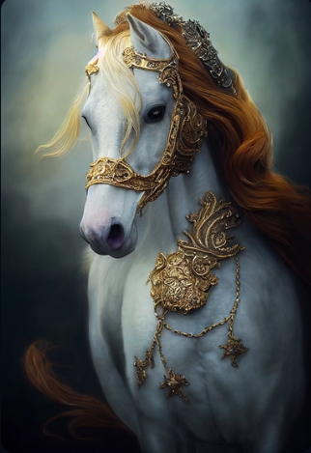

Kirin, a mythical beast from the Three Seas of China.He is sacred and solemn in armor.Portrait, fine and detailed armor, complex gold and silver wire fine metal design, silver, steel, silk, film lighting, rose gold, 4k, illusory engine, octane number rendering --ar 9:16 --s 5000 --upbeta --testp --upbeta --upbeta

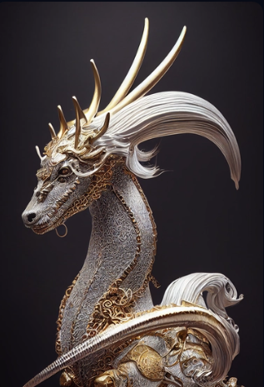

<https://i.mj.run/ce33ed92-c54d-41d7-965a-979531560f58/0_0.png> airy, pin-up, sci-fi, steam punk, very deitaled, realistic, figurative painter, fineart, Oil painting on canvas, beautiful painting by Daniel F Gerhartz Hans Zatzka's early 20th century neoclassical Austrian printing of an allegory of summer with messengers of love woman in transparent silk robe undine the nymph from Greek mythology bathing at the fountain by John William Waterhouse Chauncey Bradley Ives's 19th century digital illustration of undine rising from the fountain beautiful Christian marble statue maiden wearing cloth and Ukrainian tanks in sunflower field battle by RadoJavor 16k, ultra high-quality render, Hans Zatzka's early 20th century fine art fairy tale painting of two lesbian fairies embracing in a flowery landscape German biedermeier oil painting of a monk by Eduard von Grutzner --ar 9:16 --upbeta --test --creative --upbeta

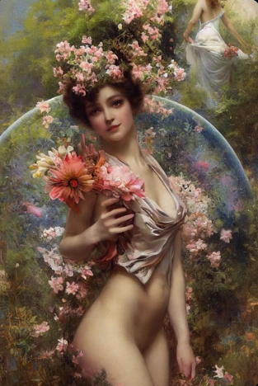

Close-up portrait of an attractive beautiful female Lord Raiden from Mortal Kombat with red paint on her face played by a perfect equal mix of Kate Upton, Sofie Snoeck, Victoria Justice and Alexis Ren, intricate detailed garment design, bioluminescent colors, photo realistic, cinematic lighting --ar 9:16 --testp --upbeta --upbeta --upbeta

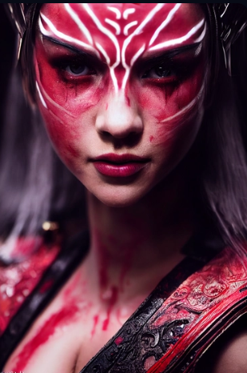

<https://i.mj.run/779205a2-dd6d-4290-85ef-e8636d4085f3/0_0.png> Illustration, watercolor, comic, fantasy, highly detailed, elaborate, shinku, cat wearing armor, Akihiko Yoshida style --ar 9:16 --test --creative --upbeta

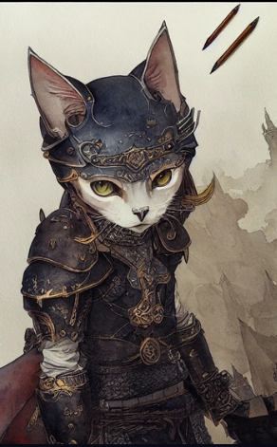

<https://i.mj.run/f435566a-6c1a-446c-838c-1ea876892e31/0_0.png> portrait of an ethereal beautiful goddess holding the universe hovering over a black sea of stars, wide shot, unreal engine 5 render, 4k, 8k, intricate, game art, epic movie poster composition, hd render --ar 2:3 --test --creative --upbeta

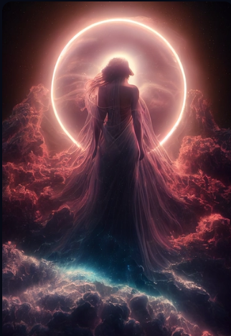

Tiny cute adorable white kitten, in a 1970s disco, anthropomorphic, Jean-Baptiste Monge, soft cinematic lighting, 8k, intricate details, portrait, Pixar style character, old fashioned movie style —ar 9:16 --upbeta --testp --upbeta



a large extremly gross, scary and weird abstract ivory Portal leading into a colorful fantasy galaxy cell inside of a large baroque hallway,fantasy, ultra realistic details + hyper real + unreal engine 5, photorealistic, octane render, Vray + Zbrush + DirectX + Terragen + After Effects + 8k UHD + immense detail, enchanced quality + immersive detail,extreme realistic and detailed --q 5 --ar 9:21 --seed 15711

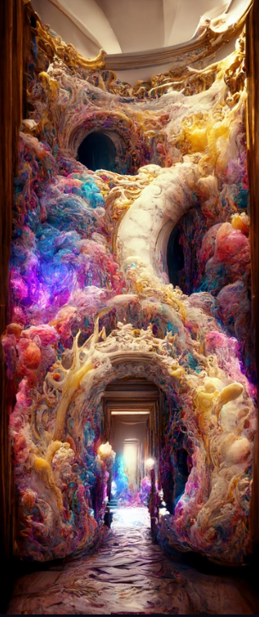

Batgirl portrait, female curves, epic lighting, shot on Canon 5D --ar 4:5 --testp --upbeta

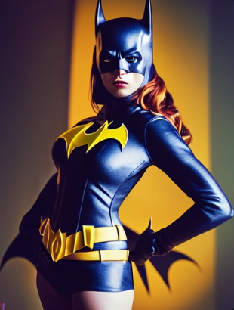

Close up portrait, Cybernetic borderlands dog robot, biotech gear, armor made of tungsten with scrap metal junkyard design, serious look, cinematic lighting, photo realistic, by H.R. Giger --ar 2:3 --test --upbeta --upbeta



<https://i.mj.run/1eafa999-a65f-490b-83b3-261461d2a2cd/0_0.png> A dog that looks like a joker, a cyberpunk dog, ultra realistic, ultra details, --ar 3:4 --test --creative --upbeta --upbeta

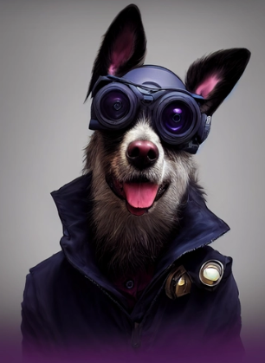

majestic skeleton paladin, portrait, finely detailed ivory porcelain armor, cinematic lighting, intricate filigree metal design, 8k, unreal engine, octane render, realistic --ar 10:16 --testp --upbeta



Anthropomorphic majestic black lion paladin, portrait, finely detailed armor, cinematic lighting, intricate filigree metal design, 8k, unreal engine, octane render,, realistic, --ar 9:16 --testp --upbeta

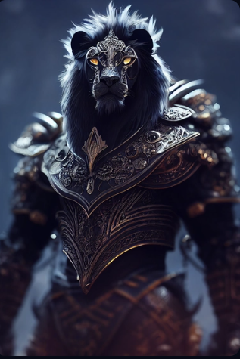

<https://i.mj.run/37456246-9d64-46c0-891a-d19a9a28442a/0_0.png> nightmare interpretation + Hyper Real + Starburst + Lumen Reflections + Symmetrical + Beautiful Lighting + Shot on Super-35 + Subsurface-Scattering + OpenGL-Shaders + VFX + RTX + SSAO + FXAA + Fantastic Realism + Photorealistic + Magic Realism + Cell Shading + New Realism + Clear Reflections + Wide Angle + 8k + De-Noise + Unreal Engine + Octane Render + Infini-D-Render --ar 2:6 --q 2 --uplight

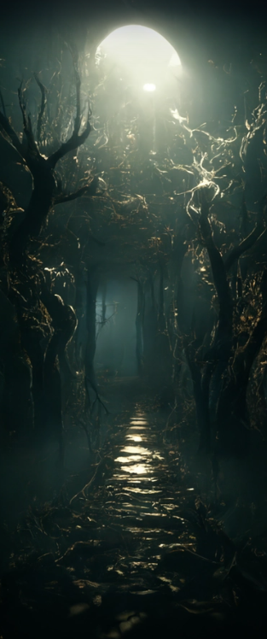

Tiny cute adorable mouse dressed as a king in a castle, anthropomorphic, Jean-Baptiste Monge, soft cinematic lighting, 8k, intricate details, portrait, Pixar style character, old fashioned movie style —ar 9:16 --upbeta --testp --upbeta --upbeta

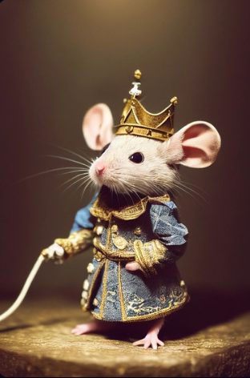

<https://i.mj.run/56c16ede-0283-445c-b862-1a899551886f/0_0.png> Oracle submerged in water, up close, pixiv image, Grimdark, ornate, Intricate details, anime, Cinematic lighting, extremely detailed, symmetric design, atmosphere, Artstation trending. glowing highlights --stop 85 --chaos 5 --q 2 --v 3

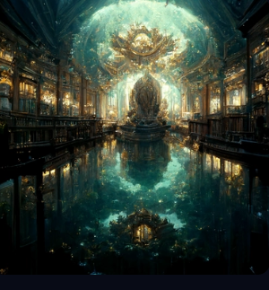

Anthropomorphic majestic God, portrait, finely detailed armor, cinematic lighting, intricate filigree metal design, 8k, unreal engine, octane render, realistic --ar 9:16 --testp --upbeta

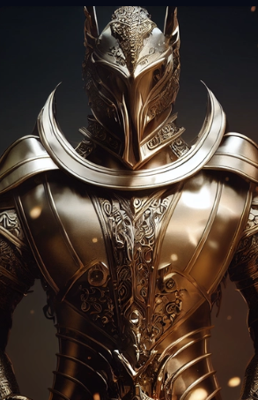

beautiful cute baby unicorn in a nest made of grass in the enchanted forest —testp —upbeta —ar 16:9 --upbeta --upbeta --upbeta

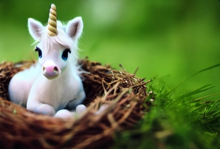

<https://i.mj.run/92ee6735-a788-4fd3-b1ed-a7128748dba7/0_0.png> photo of an ethereal iridescent fairy key. Opulent and ornate. Lots of colors and swirls. Magical aura. Decorated, beautiful exquisite, whimsical, magical, fairy lights, cheery, 8k, incredibly detailed, —ar 2:3 --test --creative --upbeta

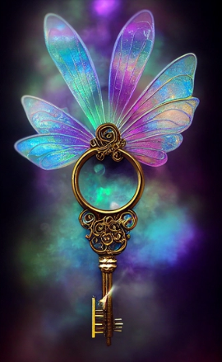

<https://i.mj.run/1555263b-2fcd-4ccb-baa7-20b352cd7d87/0_0.png> The Mandalorian, long shot, cyberpunk alley, rain, Yoji Shinkawa style, Ink painting, bold brushstrokes, Concept art, intricate detail, cinematic lighting, moody, red black neon and white, stylize --ar 2:3 --test --creative --s 5000 --upbeta

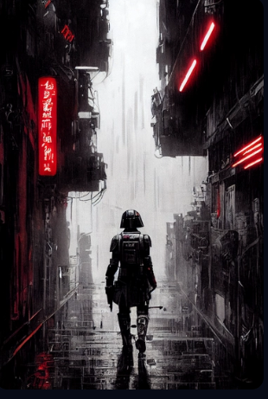

<https://i.mj.run/3a2f3816-486e-4851-a01f-4181a60fc6ab/0_0.png> beautiful woman in colored crystal, fantasy, blue medieval dress, portrait, highly detailed, hyper realistic, golden ratio, 8k, cinematic, elegant, micro details, detailed body, detailed clothes, photo realistic, full HD, 3d, super resolution, 3rd max, v ray, octane render, unreal engine, --ar 9:16 --testp --upbeta

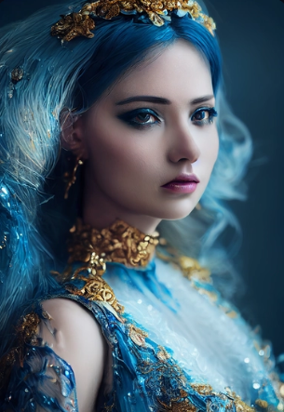

<https://i.mj.run/3a76270f-9388-4242-84fe-1d65133d2bbe/0_0.png> tree gate to a fantasy realm, highly detailed, immersive, volumetric light, detailed, concept art, asher brown durand, greg rutkowski, andreas rocha, renato mucillo, shinkai makoto style, animated, artstation --ar 9:14 —test --upbeta —video --upbeta

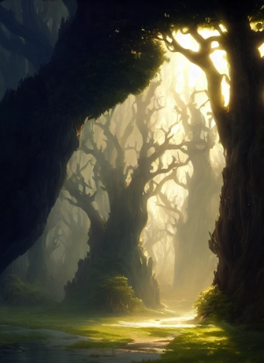

An oracle with the universe in her hands, highly detailed, cinematic, 4k, dark atmosphere

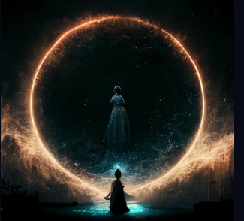

<https://i.mj.run/86901202-b6c6-4ab6-b84e-b55e15f0445e/0_0.png> Anthropomorphic majestic Cheetah paladin, portrait, finely detailed armor, cinematic lighting, intricate filigree metal design, 8k, unreal engine, octane render,, realistic, --ar 9:16 --testp --upbeta --upbeta

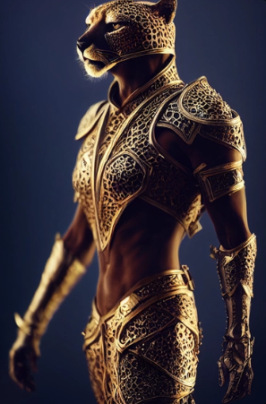

An angry fully armored Dragon Dog Orc full of anger and rage, epic, cinematic lighting, photographic, --ar 2:3 --test --upbeta



Ultra realistic photo of Princess Peach from Super Mario, beautiful face, intricate, highly detailed, smooth, ultra realistic digital art, sharp focus, art by artgerm and greg rutkowski and raymond swanland and alphonse mucha --style TheZakMan --video --ar 3:6 --test --upbeta --upbeta --upbeta

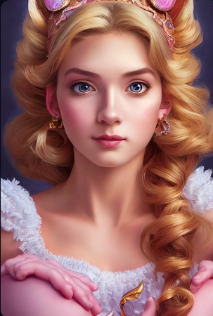

<https://i.mj.run/cbae0a99-0a6f-4b95-957e-62f9ddce6777/0_0.png> Tiny cute adorable Giraffe | Bobble Head | Pixar Style | Dramatic lighting --testp --ar 2:3 --upbeta

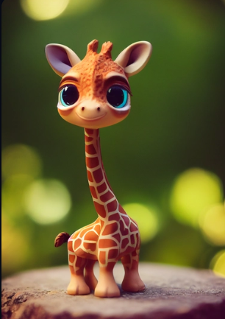

<https://i.mj.run/15f08dba-db1c-4c66-8b8c-0e63d84fb5a4/0_0.png> niagara falls galaxy, at dusk, water made of stars, planets, cosmic clouds and colours, epic scene, cinematographic lighting, hyper realistic, very fine detail, atmospheric concept art, unreal engine 5, photorealistic, octane render, Vray --ar 3:4

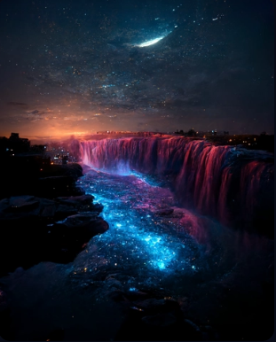

<https://i.mj.run/865851b0-6179-4d87-b207-ef3e20fa07af/0_0.png> steampunk golden retriever dog wearing steampunk goggles and clothing, photorealistic, highly detailed, dramatic lighting --test --creative --upbeta



cat in tactical gear --testp --upbeta --upbeta

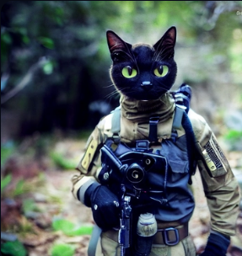

<https://i.mj.run/4321747e-92e8-4662-b944-f1086e39e04a/0_0.png> anthro khajiit, full body, long silver hair and bangs, cybernetic general zod armor, detailed, realistic, Dragonball Z, Zootopia, powerful glowing eyes, vampire teeth, sinister smile, long silver tail, running on a battlefield ruined by war, female, cinematic --ar 2:5 --s 1250 --testp --upbeta

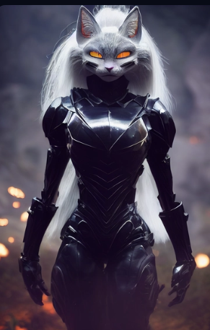

<https://i.mj.run/59d04408-76ed-45bf-bf3b-ef68fb323fae/0_0.png> exposed geisha girl, tattooed back, cinematic atmosphere, —ar 9:16 --test --creative --upbeta

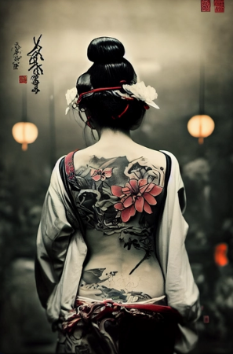

<https://i.mj.run/7ea56417-14f1-4e6f-9f4a-8b2caf8ae7c7/0_0.png> oracle within oracle within oracle forteling glorious future of united mankind, ultra detailed, octane render --ar 2:3 --test --creative --upbeta --upbeta

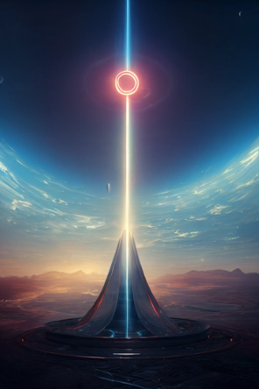

big sakura tree on hill with beautiful nature enviroment bellow, magical, key shot, epic cinematics lighting, unreal engine 4 --ar 2:3 --test --creative --upbeta --upbeta

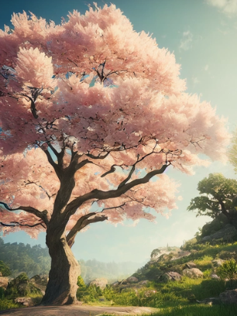

golden retriever dog with fur made of gold, shimmering dazzling lighting, ink black eyes, majesticically leaping through the air, tennis ball pannern in background, etherial, --testp --v 3 --upbeta



Soaking moonlight chaos by Gustave Baumann and Android Jones , extremely detailed, sharp focus, smooth, digital illustration, high contrast, 8 k, high detail, hyper realism, cinematic, masterpiece --ar 2:3 --upbeta --testp --upbeta

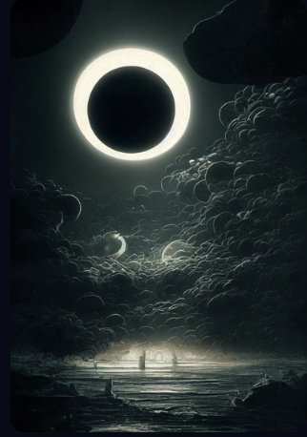

<https://i.mj.run/96db79c7-7839-4d89-9c7e-253d16af97e5/0_0.png> Portrait of a beautiful Victorian old man skeleton with epic mustache in fancy outfit, punk, big eyes, pink pastell hair color, dramatic, 8K, Cinematic Lighting, turquoise fog, intricate deatils, Lumen Global Illumination, paint strokes, dripping paint, oil painting by Ismail Inceoglu and Mike Mignola and Ashley Wood --test --upbeta

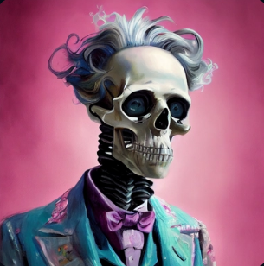

painting of a mysterious crumbling landscape with dark obelisks floating far away in the background, background of ominous dark clouds and lightnings, desaturated palette of gray blue colors, long shot, volumetric lighting, distressing feeling, painted by greg rutkowski and finnian macmanus and jessica rossier and peter elson and arthur haas and bruce pennington and john schoenherr and John Berkey and ross tran and craig mullins and Eric Lloyd Brown, cinematic matte painting, HD, 8k --test --ar 2:3 --v 3 --upbeta

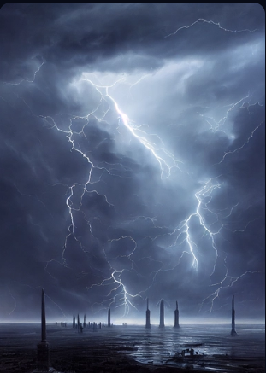

<https://i.mj.run/34c87713-1a77-4692-9ef5-a8254f87565c/0_0.png> beautiful comic bengal kitten, Pixar character, cgsociety, rendered in maya, highly detailed, 3d --test --creative --ar 9:16 --s 5000 --upbeta --upbeta --upbeta

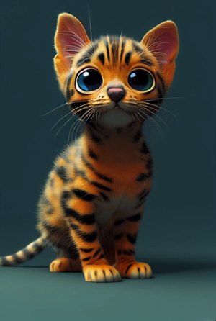

<https://i.mj.run/5981197c-09dd-4935-b990-3697cf2de0bb/0_3.png> a sailboat turned sideways, floating through galaxies, surreal, comic book, drawn by Dave Dorman, 8k,

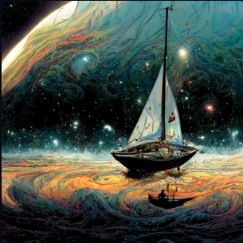

a beautiful highly detailed painting by Waterhouse, Simon haiduk and Rembrandt of an ethereal forest. The branches forming cathedral windows. Rainbow light shining through the canopy. --ar 9:16

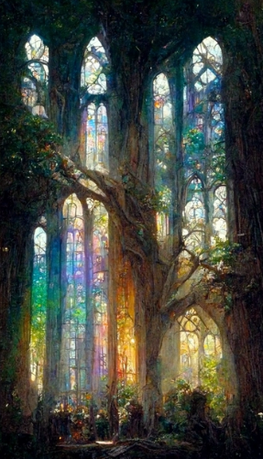

silver elven sword --s 5000 --upbeta --testp --upbeta

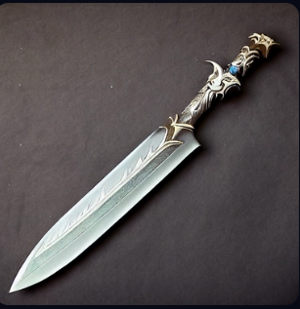

<https://i.mj.run/55fe2312-a04d-43f4-9a15-d3010214cff5/0_0.png> modern log cabin in lush pine woods, painted in the style of William Adolphe Bouguereau + Hans Zatzka, concept art, classic, atmospheric, clear, high detail --q 2 --ar 9:12

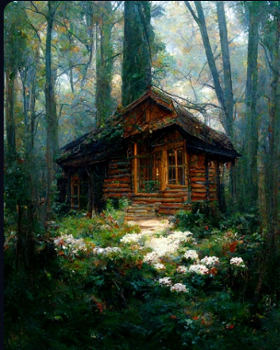

<https://i.mj.run/fc6b0322-864d-49bd-ae31-08e79596696c/0_0.png> fantasy world magic system concept --test --creative --upbeta

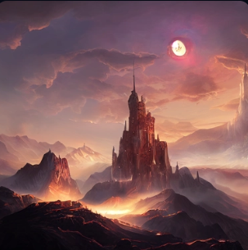

<https://i.mj.run/bdff0391-7f47-47f4-8343-7ee8a4700e8f/0_0.png> A mystical mirror with a golden frame stands before the moonlight on a sacred mountain, photorealistic, volumetric lighting —ar 2:3 --test --creative --upbeta --upbeta

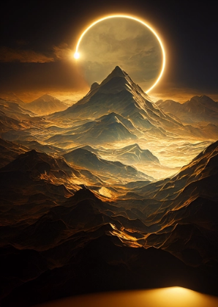

<https://i.mj.run/21f0024e-734e-4644-b122-d6dc3914f52d/0_0.png> organic spaceship in space near a planet, realistic, detailed, unreal engine 5 --ar 16:9 --test --creative --upbeta

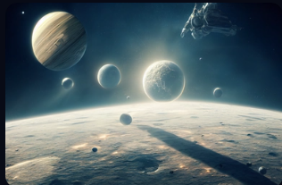

<https://i.mj.run/c65d9094-d416-4b4f-aa9f-16c9f9ac2e8c/0_2.png> an abstract dragon in an epic underworld landscape, ultra realistic details + hyper real + unreal engine 5, photorealistic, octane render, Vray + Zbrush + DirectX + Terragen + After Effects + 8k UHD + immense detail, enchanced quality + immersive detail,extreme realistic and detailed --q 5 --ar 9:21

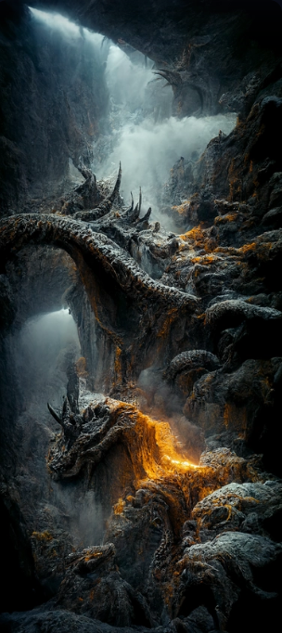

/by Bruno Liljefors, realism style, instamatic, little red ridinghood in pine forest, wild flower meadow, fog, ultra realistic, glitter sparkling in the air, octaine render, sad mood, ultra detailed, hyperrealistic, HD, 8K, --ar 3:2

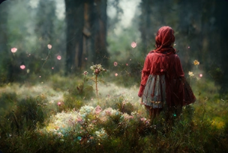

<https://i.mj.run/e87b60a5-3b55-4d4a-83f1-494ee5380b27/0_0.png> new animal species wolf mixed with deer horns, fantasy, far view, in a forest. --test --creative --upbeta

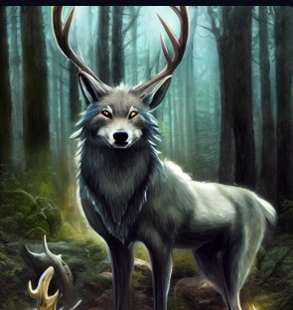

<https://i.mj.run/9cac9f45-023f-4365-b066-901e819dd36d/0_0.png> princess celestia human as a beautiful woman with a pretty face and pastel blue and pink hair wearing a gold tiara dressed in a royal dress, she also has large white feathered wings, realistic 8k beautiful lighting --ar 9:16 --test --creative --upbeta

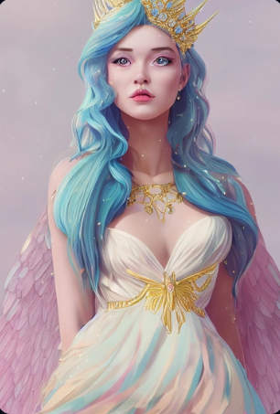

The Portal to Hell, ethereal , epic, hyperrealistic, intricate detail, Fantasy environment, finely detailed, fantasy, dynamic lighting, ultra realistic, concept art, octane render, 8k, --ar 12:18 --testp --creative --upbeta --upbeta --upbeta

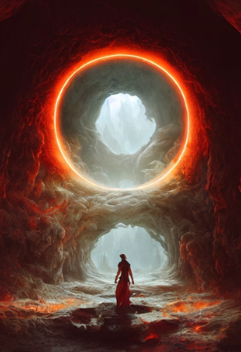

<https://i.mj.run/21a2e87d-2ae2-4121-8395-799a1e0accee/0_1.png> frodo baggins as a dog, mordor --testp --creative --upbeta --upbeta



Close up portrait of An angry fully armored Dragon Dog Orc full of anger and rage, epic, cinematic lighting, photographic, in the style of greg rutkowski and jean-baptiste monge and yusuke murata --ar 2:3 --test --upbeta



Portrait of a beautiful, curvaceous, streamer babe, pink hair and nerd glasses, intricate latex dog costume, painted by ArtGerm, Alphonse Mucha, Roberto Ferri, Ross Tran, Pixar, low angle shot, digital painting, spooky lighting, Unreal Engine 5, 8K --ar 9:16 --test --creative --upbeta --no watermark --upbeta --upbeta

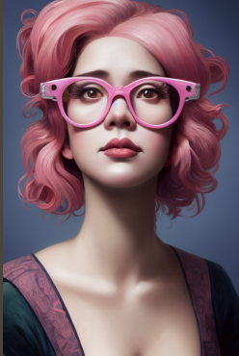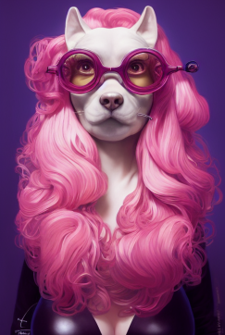这是一个关键词的结果。。。

At night, the sea waves roll, with green light in the waves, bright stars in the sky, church lights, fireflies, light effects and clouds on the island 8K,Volumetric lighting, Volumetric light --ar 9:16

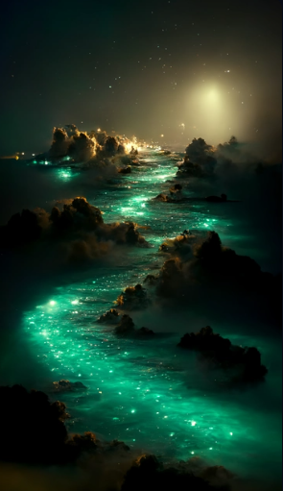

<https://i.mj.run/573e22bb-a231-4ba4-bb70-96f020a3f9a9/0_0.png> space port moon, high detail, high resolution, hyper realistic, photorealism, photorealism, nebulae, stars, cinematic lighting, unreal engine, octane render, dramatic lighting, hdr --ar 9:20 --test --creative --upbeta

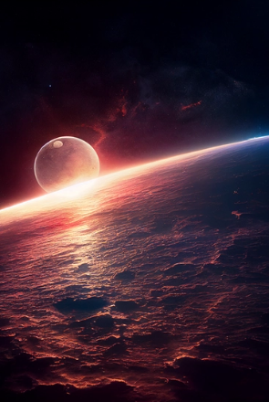

white rose partly painted red; photorealistic, --ar 1:1 --testp --upbeta

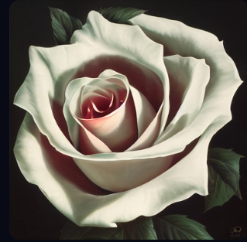

<https://i.mj.run/73113859-d353-412b-9435-95693d0b1f50/0_3.png> A spiral galaxy view from the moon of Jupiter, detailed matte painting, start and moons, light rays, Cinematic shot, dark night, octane render, Volumetric Lighting, realistic, Intricate Detail, Epic Composition, Award Winning Photography, Shot on IMAX, Depth of Field, Ray-Traced Reflections, --ar 16:9 --q 2 --s 20000

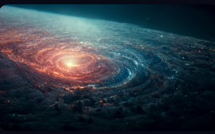

magical + fantasy + environment + Ikaros island + oracle of Artemis Tauropolus + emerges from a stargate ring of fire + vast landscape + magical + harvest moon --chaos 10 --q 5 --ar 16:9

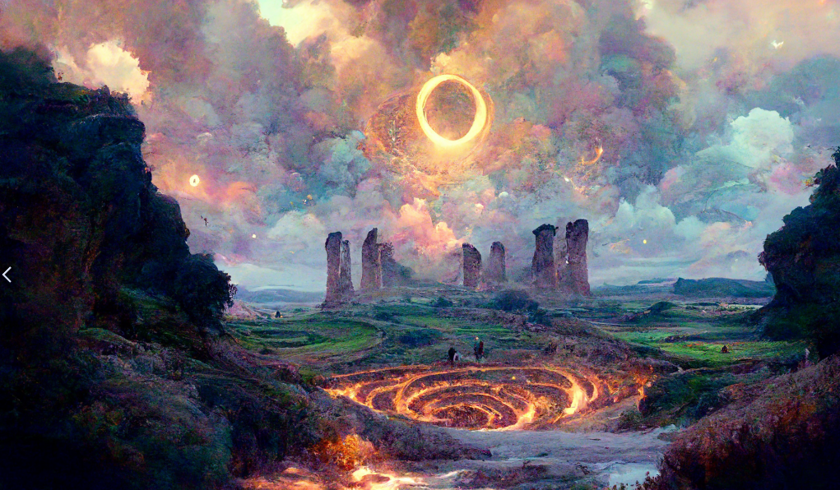

<https://i.mj.run/eac65910-765b-45f7-b97e-6e6496b27404/0_1.png> cute little angry fluffy Pikachu Pokémon manifestation with glowing golden fur, bright blue lightning markings on body, blue lightning charge wrapped around body with golden black flames, mystical blue lightning fog aura with golden highlights, alien glowing Blue Avatar forest background, transparent baby blue ice ground with tall blue omniscient alien flowers, photorealistic, insanely detailed, dramatic lighting, 8k, unreal engine, octane render --test --creative --upbeta



<https://i.mj.run/cac47f40-d9be-4dcf-b78d-13c5b98b7bc6/0_0.png> Chuu chloe Anime Elf fantasy with green skin and white glowing eyes, clothes made of ivy, imperor white filigree clothes digital art muted pastel colors, chuu chloe model, detailed, raytracing, hyper maximalist, octane rendering --ar 2:3 --testp --upbeta

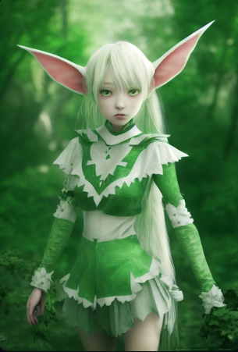

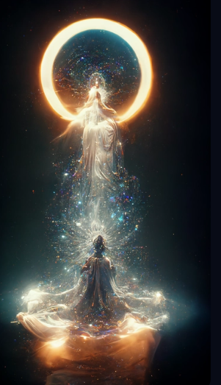

<https://i.mj.run/42a38417-bf34-4315-abbf-af9cdb9aa786/0_0.png> 45-degree view, Breathtaking baroque toned handsome masculine strong smirking Kpop idol man, full head, render hair, render shoulders, render hips, Painted by artgerm, Alphonse Mucha, Akihiko yoshida, sakimichan, krenz cushart, low angle shot, digital painting, heavenly, Symmetrical facial features, avant garde art, gold, intricate, detailed, ornate, filigree, floral, peter mohrbacher, onah bradley, diego rivera, josephine wall 4k, Lisa frank --photo --phone --test --creative --upbeta

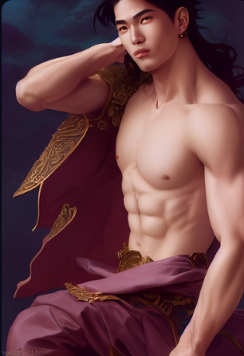

<https://i.mj.run/2cd87b89-9666-4bf9-9016-9cc84af1efd7/0_0.png> Anthropomorphic majestic black cat paladin, portrait, finely detailed armor, cinematic lighting, intricate filigree metal design, 8k, unreal engine, octane render,, realistic, --ar 9:16 --testp --creative --upbeta

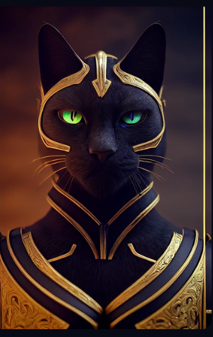

A beautiful picture depicts a green fairy tale world, a strawberry hut, and a white smoke fairyland. Lighting effect, cotton white clouds around the house, mist and yarn floating around the house, many pink bears on the house, roses, Miyazaki's animation style, fashion sense, pastoral style, very detailed, beautiful rendering style, 16K detail post-processing, art station, rendering by octane, unreal engine --ar 9:16

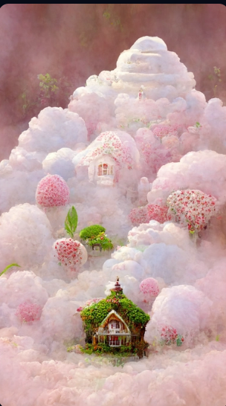

Cute little Cotton sheep, beautiful and delicate crown headdress,real, very detailed 3D animation, symmetry, center, a lot of light, colorful octane rendering --ar 9:16 --testp --upbeta --upbeta

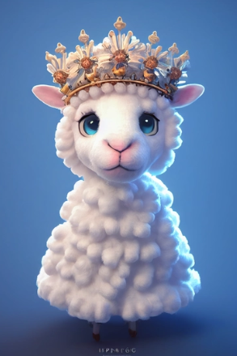

Cute little monkey, beautiful and delicate little crown, full body, very detailed 3D animation, symmetry, center, lots of light, colorful octane rendering --ar 9:16 --testp --creative --upbeta --upbeta

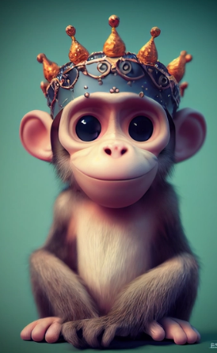

Cute dog, beautiful and delicate little crown, stylized, full body, very detailed 3D animation, symmetry, center, lots of light, colorful octane rendering --ar 9:16 --testp --creative --upbeta --upbeta



In the night sky, stars shine on silky beach, moon, elf light, stars, stars shine, golden beach, starry sky, matte painting by Michael James Smith, CG rendering, volume light, space art, Bioluminescence, Unreal Engine 5, ultra wide Angle, high definition --ar 9:16

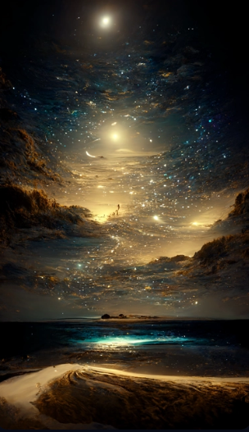

Light white jade pendant

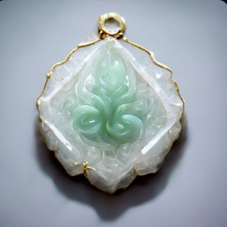

Light transparent chalcedony Pendant

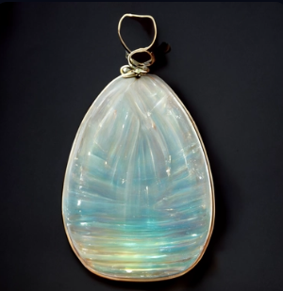

The picture is hyaline,Catholic church pattern Faint sliver white Shimmer, thousands of glowing hyaline butterfly with transparent wings around the church .smoke rays reflections,This is a beautiful picture.The church glowed like sapphire,The silvery moonlight enveloped the church,Trending on artstation,high detail hD --ar 9:16

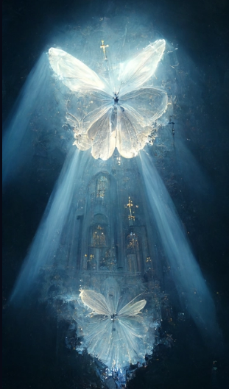

Scenery, winter, frozen fairy lake, red Milky Way starry sky, pink ice crevices on the lake. Surreal, Photo Level, Unreal Engine, Epic Rendering, Ultra HD, Ultra Wide Angle Light, 4KHD S5000 --ar 9:16

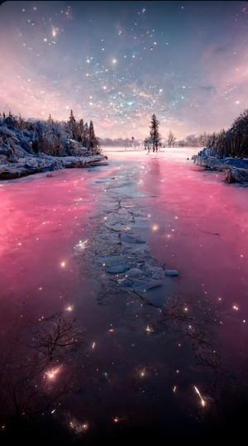

The picture is transparent. A large silver white crescent moon and the Milky Way star are scattered on the beach. There are many pink and blue peaches scattered on the beach, purple and blue, pink peach flowers, and many purple and blue peaches floating on the sea flowers. The color is soft and beautiful. Silver, ultra wide, unreal engine, HD --ar 9:16

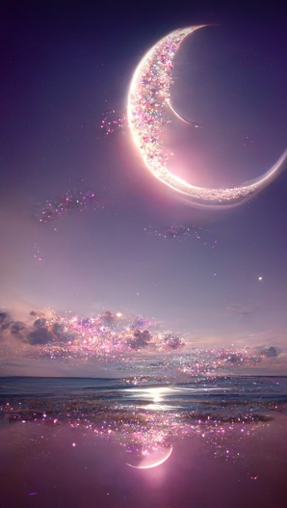

a beautiful and ethereal, opalescent, iridescent, and sparkling pastelpunk peace tree in a magical surreal forest with fireflies HD --ar 9:16

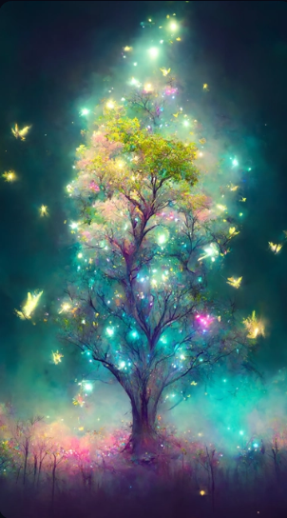

A beautiful rural field painting, paddy fields at night, blue sky, many stars are shining in the sky, nebulae,green plants,pink flowers, lots of fireflies flying in the sky, Makoto Shinkai and Hayao Miyazaki style HD --ar 9:16

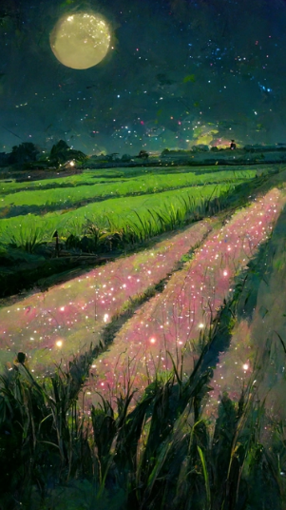

<https://i.mj.run/f80daa05-836f-4b7b-90f0-3ea92a40f500/0_2.png> Night, the Milky Way, starlight, The silver-white crescent moon is accompanied by the galactic starlight sprinkled on the beach, Coconut trees on the beach, there are many glowing creatures in the beach, the beach is the shape of love, pebbles, glowing creatures, fluorescent, golden, color, dreamy, super wide-angle light , Unreal Engine, 4K HD, HD, Volumetric light, bioluminescence, Ultra-wide viewing angle, HD --ar 9:16

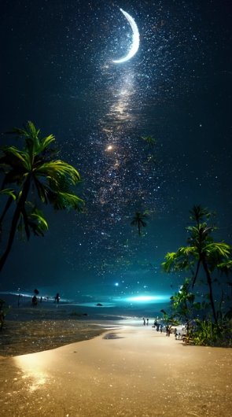

A sparkling beach bay at night with crystals and magical glowing shells along the shore, full moon, water and colorful flowers, extremely detailed oil painting, Unreal 5 rendering, fantasy digital art, octane rendering, beautiful composition, trend art station , winning photo, masterpiece HD --ar 16:9

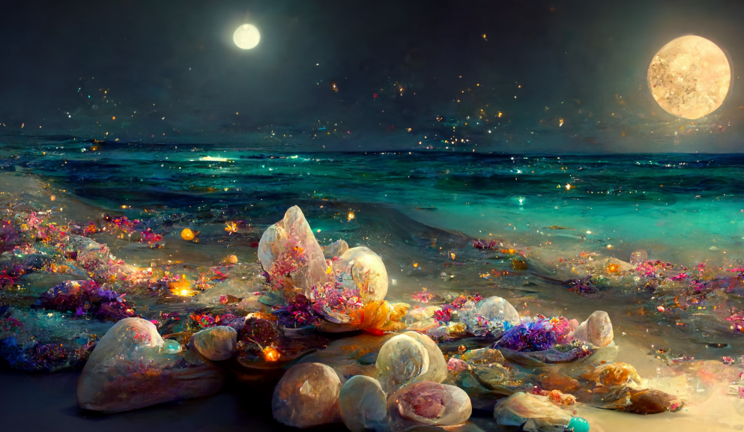

Cute chicken, beautiful headdress, extremely detailed 3D animation, symmetry, center, lots of light, colorful octane rendering --ar 9:16 --testp --upbeta --upbeta

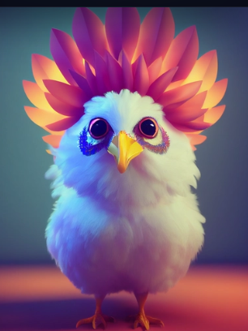

hrystal blue lagoon surrounded by giant epic glacier during pink sunrise, wallpaper, landscape photography, ultra realistic, insane details, 8k --ar 9:16

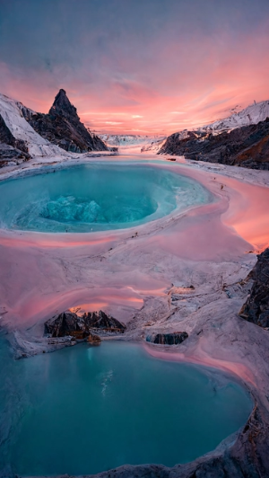

On a summer night, light blue stars, green trees on the ground, a pink train passing under the tree, small and fresh, soft fiber Optics, Fantasy, 8K, Fairy Tale, by Makoto Shinkai and Monet on Behance, 8K HD --ar 9:16 --upbeta

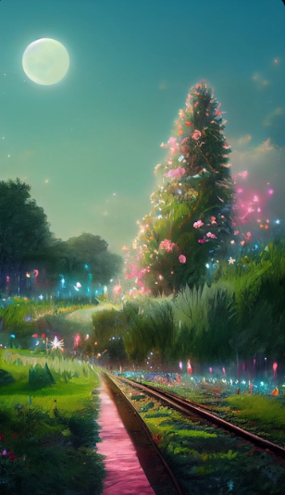

The gateway to chance, fantasy, digital art, high definition, detailed eternal paradise, green phosphorous fire --ar 9:16

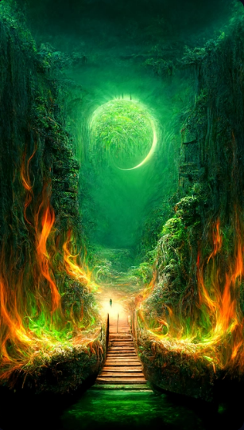

<https://i.mj.run/517d1949-fdbd-42bf-9495-8311b48b2c32/0_2.png> There is a flower that is dark blue, its petals are transparent, as deep as sea water, as crystal as dew, it can feel the loyalty and purity of love, 8K ,HD --ar 9:16

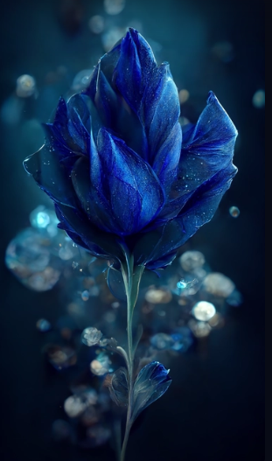

Dream forest, summer green mushroom house, cotton candy cloud, magic flower, lighting, beauty, fairy tale art style, volume lighting, high detail, unreal 3D digital art engine, 1990s animation style, Sailor Moon HD --ar 9:16

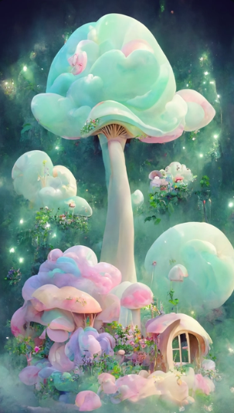

A beautiful picture depicting a pale pink and green fairy tale world, strawberry hut, white smoke and wonderland. Lighting effects, cotton-like white clouds around the house, mist and tulle floating around the house, roses all around, Hayao Miyazaki anime style, fashion sense, pastoral style, very detailed, aesthetic style 4k detail post processing, artstation, rendering byoctane, Unreal Engine HD --ar 9:16

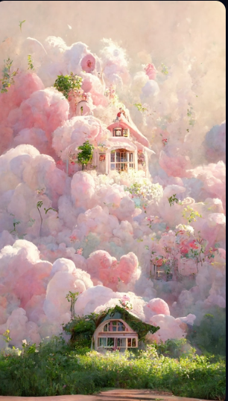

Arabian,beautiful goddess of affection, hyper-feminine, accessories,pyramid,gold,Glitter and light are coming inxsparkles,beautiful landscape,ultra realistic,symmetric,8k, —ar 9:16

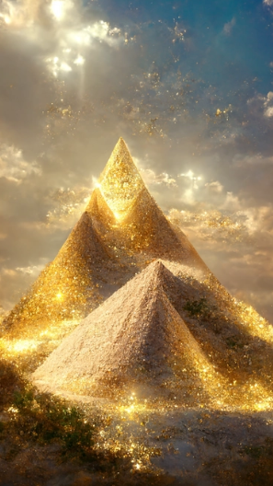

A cute and adorable baby white fox with a big fluffy tail,holding a pink flower lay on a cloud in paradise,big eyes,Peach blossom,stream,enchanting,immortal,fluffy,shiny mane,Petals,fairyism,unreal engine 5 and Octane Render --testp --ar 10:16 --upbeta

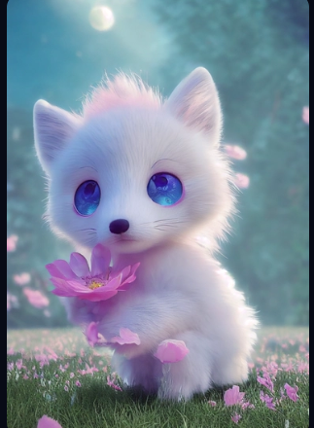

<https://s.mj.run/twCgsM8Hs4A> The picture is transparent. A huge silver-white crescent moon is scattered on the beach. The Milky Way shines with many pink roses. There are many pink rose flowers on the beach, fantasy, highly detailed, beautiful, 8k, octane rendering, real photos, complex details, ultra-wide viewing angle, panoramic shooting, and several pink roses in the foreground. Duo HD --ar 9:16

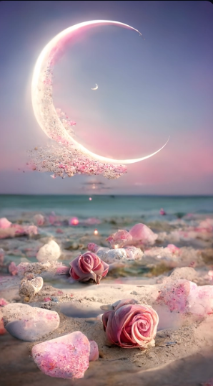

A cute and adorable baby white fox ,Big head， fluffy tail,holding pink flower lay on a cloud ,garden background,big eyes, ,Peach blossom,stream,enchanting,immortal,fluffy,shiny mane,Petals,,in the style of Pixar , photorealistic, octane render 8k, hyper detail, colorful —ar 9:16 —testp --upbeta --v 1 --upbeta --v 1 --upbeta

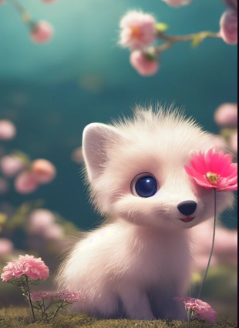

A cute and adorable baby white fox with a big fluffy tail,holding a pink flower lay on a cloud in paradise,big eyes,Peach blossom,stream,enchanting,immortal,fluffy,shiny mane,Petals,fairyism,unreal engine 5 and Octane Render --testp --ar 9:16 --upbeta --upbeta --upbeta --upbeta --upbeta



There is a kind of pink-purple rose. The petals are as deep as sea water, and the hearts of flowers are like dewdrops. They are frozen in the water, and you can feel love and beauty. HD --ar 9:16

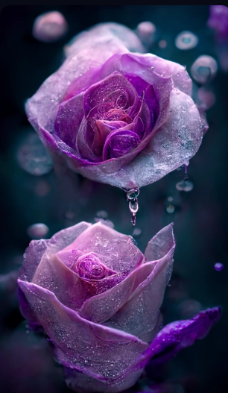

<https://i.mj.run/95897bbc-2445-4020-bc61-87fcb9c4c5b3/0_1.png> HolyHoly lightlight whitewhite angel,angel, angelangel rays,rays, light,light, wings,wings, bloomingblooming flowers,flowers, sparklingsparkling stars,stars, flowing,flowing, ethereal,ethereal, surreal,surreal, pink,pink, pastelpastel colors,colors, paintingpainting HD --ar 9:16

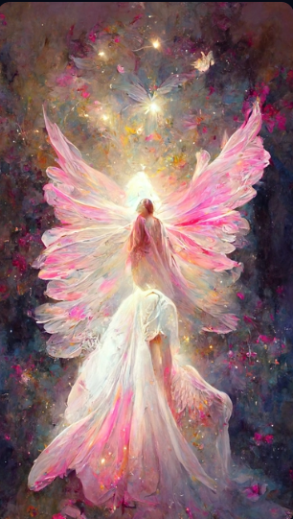

Vivid photos, animation style, clear reflection, in front of the mottled red brick low wall, sunny, lush vegetation and flowers, Andersen's fairy tale, highly detailed, sunny, soft tone, soft light, 8K post-processing, depth, detail, layering, octane rendering, popular and gorgeous on artstation --ar 9:16

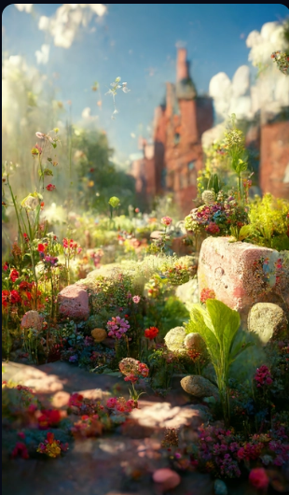

multi winged angel guard Eden Garden's flower field is close to gate of Heaven cinematic, 8k, colorful, super detailed, dramatic, photorealistic, 14mm, f5.6 --ar 16:9

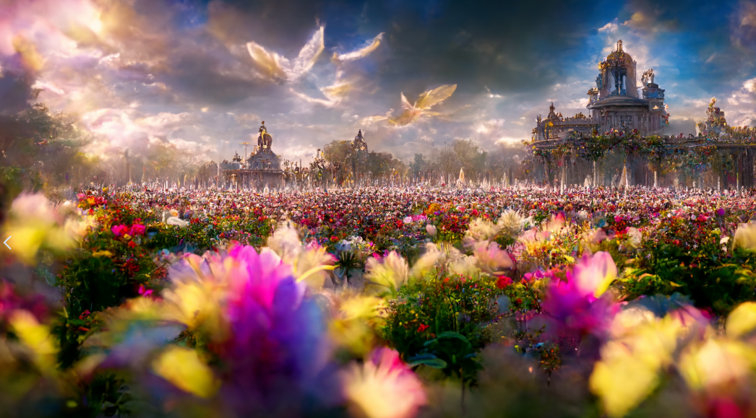

<https://i.mj.run/e3611a73-405e-46fc-9645-dd407fa20ae2/0_3.png> The blooming shore flowers surrounded by green grass, the green sky reflected in the water, the flying fireflies shining all over the sky, the sunset is clearly visible, the magic light covers the whole painting, artists, Artstation, HD，8K --ar 9:16

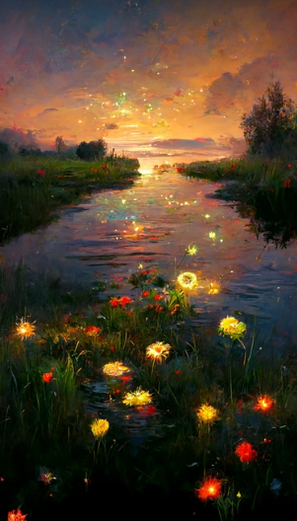

Cotton Candy House, flowers and plants, Summer Green, Fairy Tale Style, Marshmallow Clouds of Love, Soft Light, Super Details，Miyazaki Hayao painting style, octane render, HD --ar 2:3 --upbeta --testp --upbeta

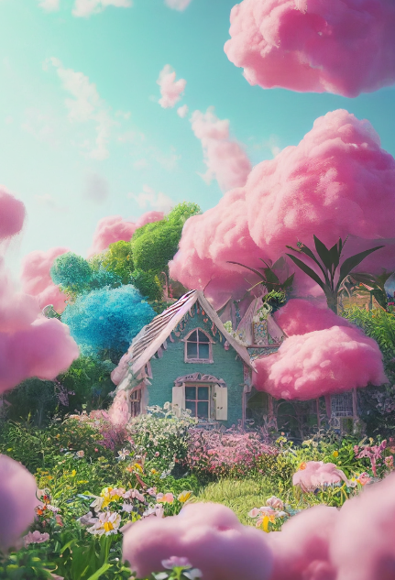

<https://s.mj.run/yU3X1kfNqVk> an oracle awash in a flow of stars, goddness, perception unlocked, ascendant, omniscient, epic, spectacular, awe-inspiring, stunning, insanely detailed, hd octane render, unreal engine 5, hyper-realistic --ar 9:16

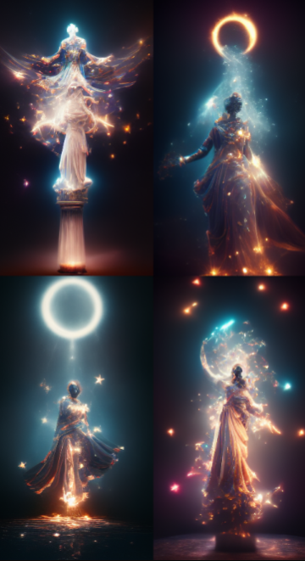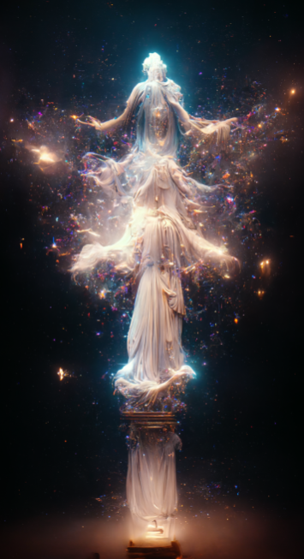

The picture is transparent. A huge silver-white crescent moon is scattered on the beach. The Milky Way shines with many purple-blue roses. There are many purple-blue rose flowers on the beach, fantasy, highly detailed, beautiful, 8k, octane rendering, real photos, complex details, ultra-wide viewing angle, panoramic shooting, and several purple-blue roses in the foreground. Duo HD --ar 9:16

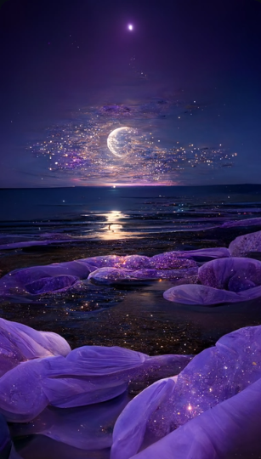

With a super wide-angle view, the fiery red sun is about to set on the boundless blue and clear ocean, and along the sun there is a sea of red roses. On both sides of the Rose Sea are the endless sea, dusk, sunset, drops of water in the clouds, thick smoke and lights,8K,UE4, ZBrush, marmoset Kit HD--hd --ar 9:16

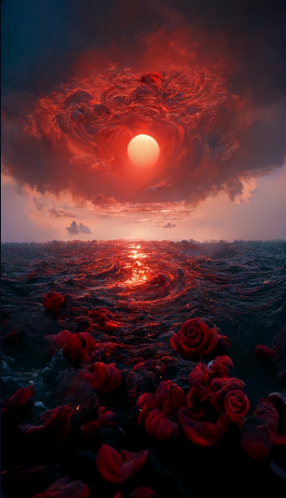

A beautiful picture depicts a train surrounded by pale pink roses. Lighting effects, the train has a lot of light blue roses, on the top of the sky with white clouds floating, rainbow and sunshine, hayao miyazaki painting, fashion art, CG rendering, and cyber punk, 8 k high definition, beautiful paradise, the 3 d effect, aesthetic illustrations, film aesthetics effect, crystal lamp, the AUV, 4 k post processing in detail, art, rendering by octane, Unreal Engine - Mass 1.5---hd --ar 9:16

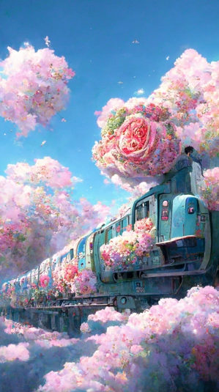

<https://s.mj.run/ihRyb0Alamg> In the morning, flowers are in full bloom in the green forest. In the middle are purple roses of different sizes. Hundreds of flowers are in full bloom. There are many drops of water on the roses. Butterflies are flying around. It is silky and smooth like milk. The painting style is Hongguang. The lighting effect is realistic, 8k hd --ar 9:16

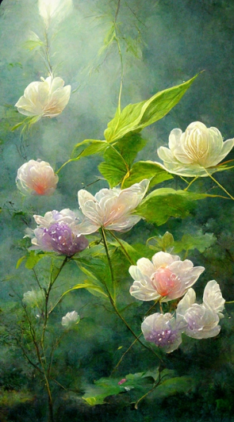

Light blue sea, blue sky and white beach, scattered pink roses. Spread beach, a champagne colored broken diamond fine twinkling rose path leading to Crescent Bay, is surrounded by several colorful colored stones, panoramic view, ultra wide view, and beach in light blue and pink sky. Dream engine, epic rendering, Ultra HD, ultra wide angle, art station,4K.HD --ar 9:16

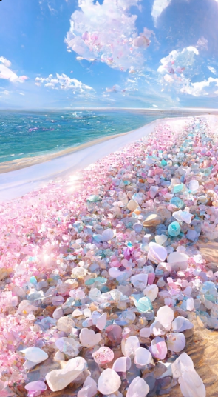

There is a kind of pink-purple rose. The petals are as deep as sea water, and the hearts of flowers are like dewdrops. They are frozen in the water, and you can feel love and beauty. HD --ar 9:16

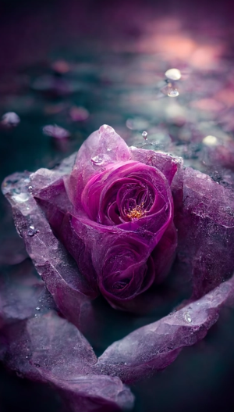

A white small boat floating on the pink sea with white roses, pink gradient sky, romantic, cinematic scene, Unreal Engine, hyper realistic, very fine detail,atmospheric concept art, by Noah Bradley and Andreas Rocha and Albert bierstadt --ar 3:4 --upbeta --test --upbeta --upbeta --test --upbeta --upbeta --upbeta

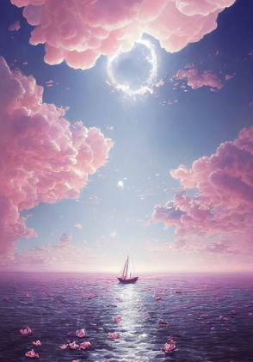

There is a huge dragon in the red sky.,Garden in factory,Many rose,A few yellow roses and blue roses, ultra wide shot, atmospheric, hyper realistic, 8k, epic composition, cinematic, octane render, artstation landscape vista photography by Carr Clifton & Galen Rowell, 16K resolution, Landscape veduta photo by Dustin Lefevre & tdraw, 8k resolution, detailed landscape painting by Ivan Shishkin, DeviantArt, Flickr, rendered in Enscape, Miyazaki, Nausicaa Ghibli, Breath of The Wild, 4k detailed post processing, artstation, rendering by octane, unreal engine --ar 9:16

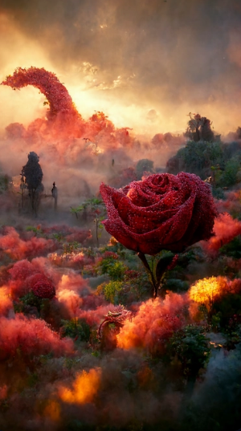

Blue sea, blue sea, dreamy rainbow cover the beach, and there are many colorful roses and shining crystal pebbles on the beach. Starlight silver crescent moon and galaxy starlight are scattered on the beach, luminous creatures, fluorescent, golden, colorful, dreamy, super wide-angle light, unreal engine, 4K HD --ar 9:16

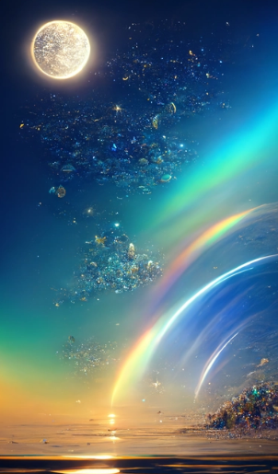

<https://i.mj.run/185ee754-5dad-4d42-a8ce-33db7a425aea/0_0.png> Gorgeous crystal palace,CG rendering European styleoverlooking,fairy tale,rose surround,lighting effect,heavenly,starry sky,super detail,illustration,4K,unreal engine,ethereal cloud,HD --ar 9:16

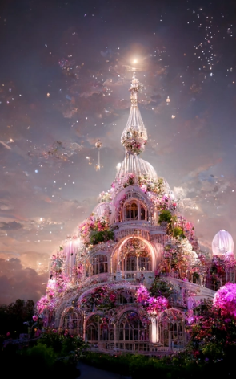

<https://i.mj.run/be1d8c71-c590-43a7-ae68-9b9dabf6827b/0_0.png> blue ocean, white snowy beach, frozen, Milky Way shines on many tiny and colorful rose crystals, artic, tundra, iceberg, fantasy, highly detailed, beautiful, 8k, octane render, photorealistic, intricate details, Ultra-wide viewing angle, Panoramic shots,8k--hd --ar 9:16

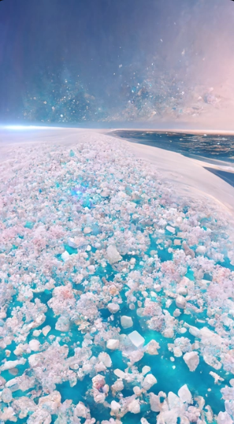

The sky is China's Surrealist fairyland, with blooming blue roses, surrounded by roses, Dennis hitnick's colorful sunshine, emerald and white jade, sparkling crystals, dreams, starry sky, CG rendering, 4K, HD, beautiful fairyland, clouds floating in the sky, HD,UE4,8k --ar 9:16

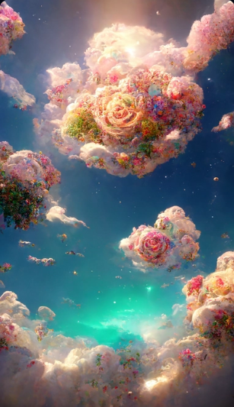

The huge magic palace, CG rendering shows a romantic pink ocean in the distance, the ground is covered with roses, and the surreal romantic oil painting effect shows the heart-shaped moon hanging in the sky. Fog, romantic and beautiful mood, 8K, fairyland, 3D, fantasy, powerful visual effect - Hd --ar 9:16

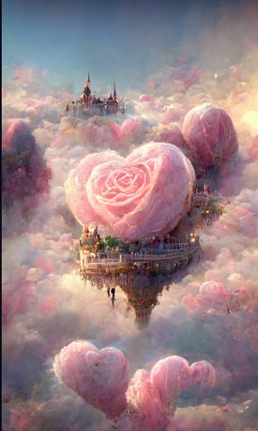

The picture is transparent. The huge silvery-white crescent moon is sprinkled on the beach with the Milky Way stars. There are many pink and blue roses floating on the beach, pink and blue roses floating on the sea, heart-shaped beach, luminous creatures, silver, unreal engine, super wide, 4K HD, HD --ar 9:16

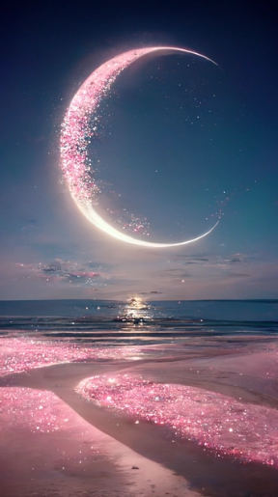

<https://i.mj.run/ff144a27-fec7-4d7c-ad03-9cdb3733e66d/0_2.png> Magical Palace, Heaven, White, Tiffany Blue, Pink, Glowing Water, Pink roses, Moonlight and stars, Rose petals and raindrops, Magic, Realistic Photos, Redshift rendering, CGI,3D, Ultra Detail, Photorealistic, 8K, Masterpiece, Functional Art Station, Ultra Wide 3000 HD --ar 9:16 --uplight

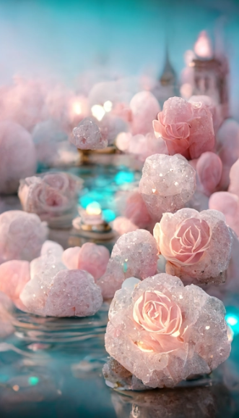

blue ocean, white snowy beach, frozen, Milky Way shines on many tiny and colorful rose crystals, artic, tundra, iceberg, fantasy, highly detailed, beautiful, 8k, octane render, photorealistic, intricate details, Ultra-wide viewing angle, Panoramic shots,8k --ar 9:16

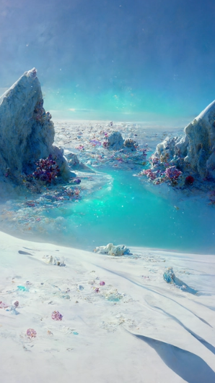

<https://s.mj.run/twCgsM8Hs4A> The picture is transparent. A huge silver-white crescent moon is scattered on the beach. The Milky Way shines with many pink roses. There are many pink rose flowers on the beach, fantasy, highly detailed, beautiful, 8k, octane rendering, real photos, complex details, ultra-wide viewing angle, panoramic shooting, and several pink roses in the foreground. Duo HD --ar 9:16

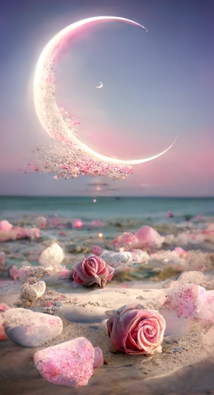

spring court of acotar, garden of roses, big white manor, garden with lake, fauna, beauty and the beast garden, quiet, silence

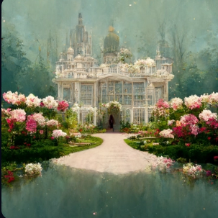

The background is a starry sky created by Van Gogh，A little prince is looking at the stars， the ground is covered with roses，Van Gogh style,8k, hd --ar 9:16

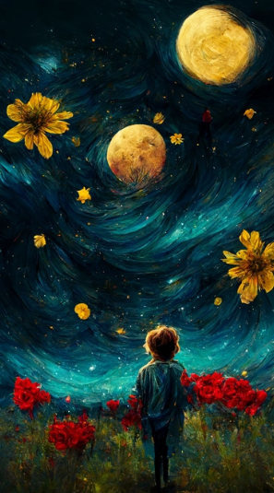

<https://i.mj.run/8df21524-76ed-4e07-84ae-754ddfd6bdbe/0_3.png> **< << magical palace, heaven, white, tiffany blue, pink, glowing water, pink rose, magic, photorealistic, redshift rendering, CGI, 3D, super detail, photorealistic, 8K, masterpiece, feature artstation , ultra-wide 3000 hd --ar 9:16

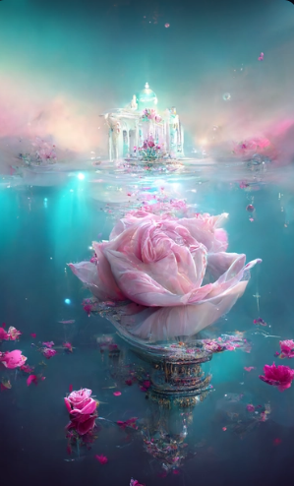

Super cute little fox The sky is China's Surrealist fairyland, full of blooming roses, jadeite and white jade, glowing crystals, golden waterfall effect, CG rendering, 8K HD, beautiful fairyland, mist and gauze floating in the sky, HD, --ar 9:16

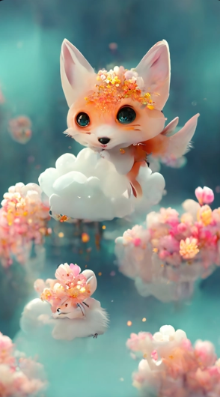

In the night sky, the beach is covered with silver and gold fluorescence, huge moon, A waterfall of purple roses flows from the moon to the pink sand fairy light, stars, light spots, shining golden beach, stars and the Milky Way moon, crescent and moon, Michael James Smith matte painting, reflection, cg rendering, volume light, space art, bioluminescence, unreal engine, 5, the magic of light, unreal engine rendering, ultra wide angle, ultra wide angle, high definitionHD --ar 9:16

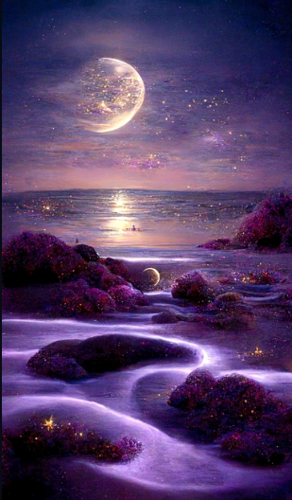

There is a kind of pink-purple rose. The petals are as deep as sea water, and the hearts of flowers are like dewdrops. They are frozen in the water, and you can feel love and beauty.HD --ar 9:16

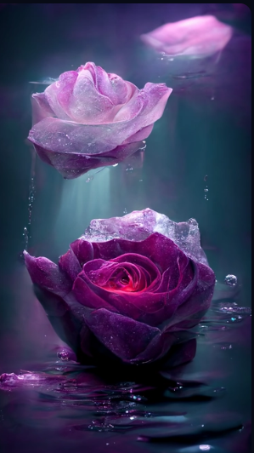

<https://i.mj.run/dee9d163-f965-4a0e-bbeb-452bbf3a092b/0_3.png> Blue ocean, shimmering these stars, white snow color transparent ice cubes with roses, frozen frozen, fell in the sea and snow moon reflected in the Milky Way, the arctic, tundra, glacier, at dusk, fantasy, highly detailed, beautiful, 8 k, octane render, lifelike, the details of the complex, super wide viewing Angle, 8k --ar 9:16

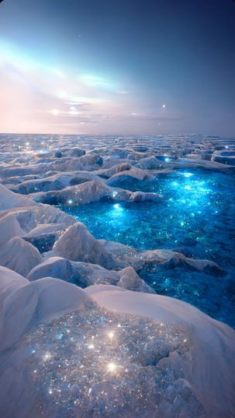

Have the opportunity to accompany me to the seaside, I want to see the scenery. Want to chase the wind in the mountains, see dusk and dawn. Beautiful roses bloom on the sunset road, and the summer of roses will never be absent.HD --ar 9:16

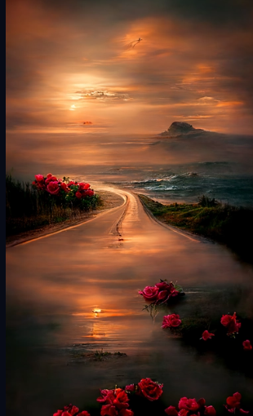

At night sky, the beach is covered with blue and yellow fluorescence the moon,white rose, elf light, stars, facula, the sea with fluorescence, the shining golden beach, the starry sky with moonlight, Michael james Smith's matte painting, reflection, cg rendering, volume light, space art, bioluminescence, unreal engine 5, magic of light, unreal engine rendering, super wide angle, super wide angle, high definition. --ar 9:16

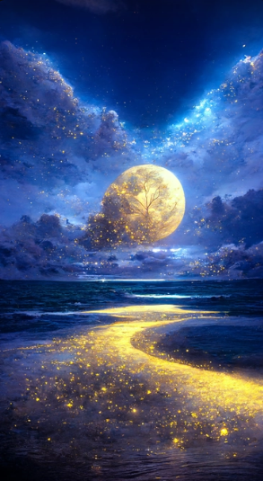

A pair of surreal CG Rendering map，Maldives, transparent sea, fresh, romantic, refracted light, very clean glass sea water, The beauty of dawn,light blue sea,Some pink small roses surround the seaside, pink and tender. sunny, warm and comfortable beach,8k,Highly detailed and complex rendering, HD --ar 9:16

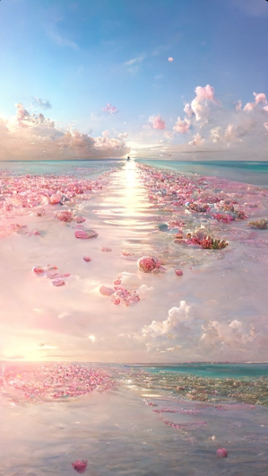

<https://i.mj.run/14acd5b6-e5b3-494a-b649-171d862db0c0/0_0.png> Blue gradient rose + serenity + aestheticism + high detail, soft moonlight,dark blue background, soft lighting, 8k new happiness, deep details, layered details, high quality, high definition and new love rendering HD, —ar 9:16

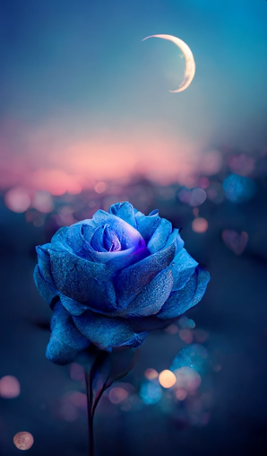

<https://i.mj.run/61fe1186-bf33-41c7-a4fb-2a9f8c5b21ba/0_3.png> The picture is transparent , a large silvery white crescent is sprinkled on the sand accompanied by the Milky Way stars , there are many pink and blue roses floating on the sand , pink and blue roses floating on the sea , a beach in the shape of a heart , glowing creatures , Silver , Unreal Engine , Ultra Wide ,4K HD --ar 9:16 --iw 5

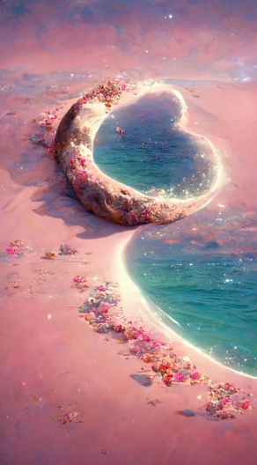

Zeen Chin Hyperrealistic style A beautiful painting of starry sky, layer upon layer of huge waves, deep blue water, pink roses of different sizes, romantic, dreamlike, moonlight, Thomas Kinkade, ultradetailed, illustration, 4k， trends on Artstation, above+super wide angle, Greg Rutkowski, trends on Artstation --ar 9:16

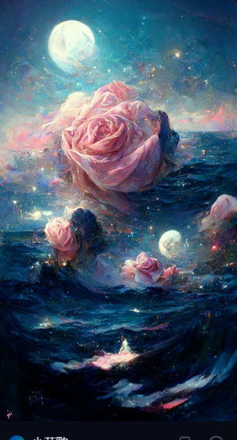

At night, the waves roll, the blue light in the waves, the bright stars in the sky, auroras, fireflies, shells, purple and pink roses, the sky is huge halo, light effects and clouds on the island, volume lighting, volume light，HD, 8K,HD --w 1800 --h 3200

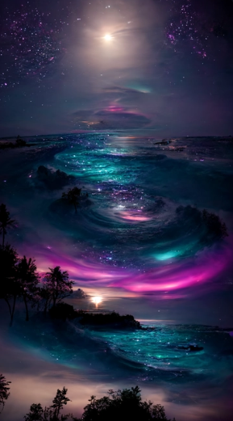

A Beautiful Painting Beautiful Sky Clouds Roses Crystal Castles Streams Misty Butterflies Gold Ultra Wide Angle Healing Reflections Wonderland Thomas Kinkade Peter Elson Art Station Ultra Wide Unreal Engine HD --ar 9:16

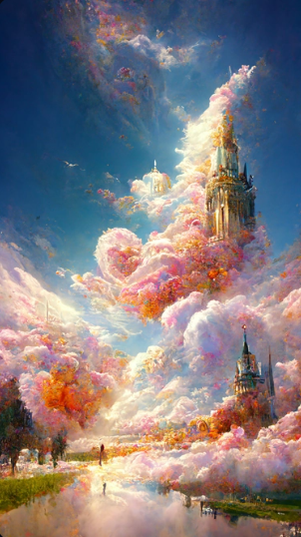

Medium sized crystal Gothic palace, dream, cloud, romance, many heart-shaped roses, romantic lights, white smoke, fantasy bubbles, ultra wide angle, octane rendering, ultra detail, HD, ultra realistic CG rendering，HD --ar 9:16

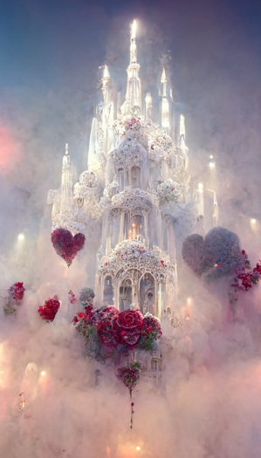

Render in Unreal Engine, ultra wide view, ultra wide view,blue ocean, white snowy beach, frozen, Milky Way shines on many tiny and colorful rose crystals, artic, tundra, iceberg, fantasy, highly detailed, beautiful, 8k, octane render, photorealistic, intricate details, Ultra-wide viewing angle, Panoramic shots,8k --ar 9:16

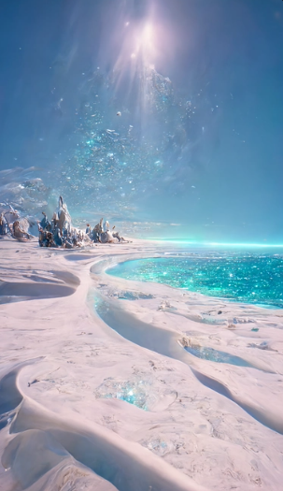

<https://i.mj.run/8527485d-ba35-40d7-ac03-e089c9cbf76f/0_3.png> The picture is transparent, a large pink crescent is sprinkled on the sand, accompanied by the stars of the Milky Way, many pink roses are floating on the sand, and blue roses are floating on the sea, a creature shaped like a heart, glowing, silver, Unreal Engine, Ultra Wide, 4K HD, --ar 9:16

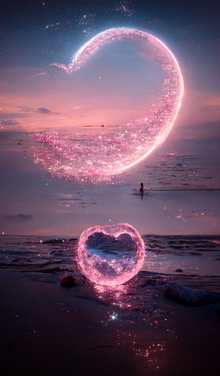

<https://s.mj.run/Wmm-9627RNk> The blue sea, the blue sky, the luminous bodies of the sky form a heart shape, the silver sand beach of the Maldives forms a heart shape, there are many blue roses on the beach, there are many blue rose, many tiny and colorful glowing particles, vivid color scheme, fantasy, high detail, 8K, octane shadows, intricate detail, surreal, 8kHD, --ar 9:16 --upbeta

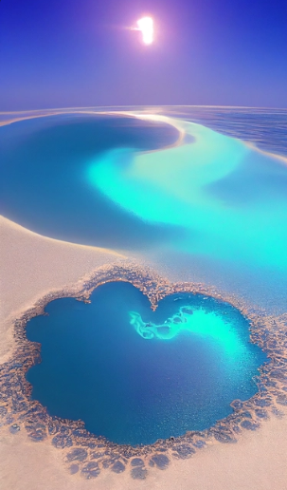、

The picture is transparent. A huge silver-white crescent moon is scattered on the beach. The Milky Way shines with many purple-blue roses. There are many purple-blue rose flowers on the beach, fantasy, highly detailed, beautiful, 8k, octane rendering, real photos, complex details, ultra-wide viewing angle, panoramic shooting, and several purple-blue roses in the foreground. Duo HD --ar 9:16

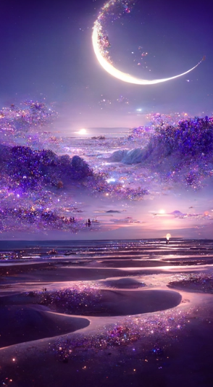

**Alien beach of love, glowing creatures, romance,North Pole, many pink and light blue roses, romantic lights, light blue, white stars, fantasy bubbles, super wide angle, super detail, HD, 8k, super realistic CG rendering HD --ar 9:16

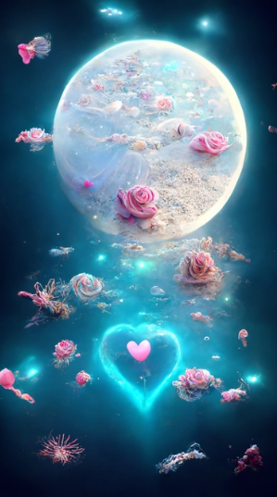

There is a romantic heart-shaped blue ocean, a white beach in Maldives, blue roses and pink roses of different sizes on the beach, and many tiny and colorful luminous particles illuminate the Milky Way, Arctic, tundra and iceberg, fantasy, high details, beauty, 8K, shadow of octane number, complicated details, close range, close range,HD --ar 9:16

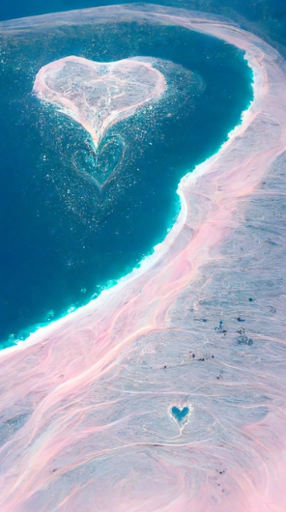

Blue ocean,blue sky,white beach of Maldives,pink，roses of different sizes on the beach,blue roses, many tiny and colorful luminous particles，illuminated by the Milky way,Arctic,tundra and，iceberg,fantasy,high detail,beauty,8K,octane shading,complex details,ultra wide angle of view, panoramic shooting,8K.HD --ar 9:16

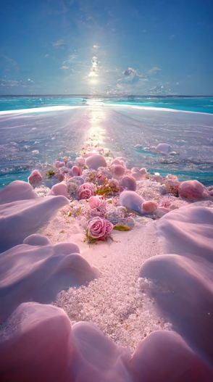

<https://s.mj.run/Wmm-9627RNk> azure sea, azure sky, the luminous body of the sky forms a heart shape, the silver sand beach of Maldives forms a heart shape, there are many pink roses on the beach, there are many pink roses, many tiny and colorful glowing particles, vivid color scheme, fantasy, high detail, 8K, octane shadows, intricate detail, surreal, 8kHD, --ar 9:16 --upbeta

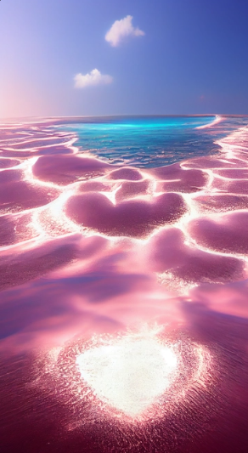

<https://i.mj.run/eefc6da8-0c99-4a5b-ae9b-6a9abb6d8348/0_0.png> Blue sea, blue sea, dreamy rainbow cover the beach, and there are many colorful roses and shining crystal pebbles on the beach. Starlight, silver crescent moon and galaxy starlight are scattered on the beach, luminous creatures, fluorescent, golden, colorful, dreamy, super wide-angle light, unreal engine, 4K HD --ar 9:16 --v 3

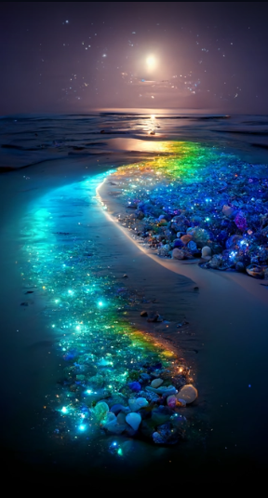

<https://i.mj.run/5a4b78a8-d342-4ff0-b8be-4e8a90acff57/0_1.png> Huge crystal Gothic palace, dream, clouds,Romantic， many red roses, romantic lights, light blue clouds, white stars, fantasy bubble, super wide angle, octane rendering, super detail,HD, A ultra-realistic CG rendering --ar 9:16

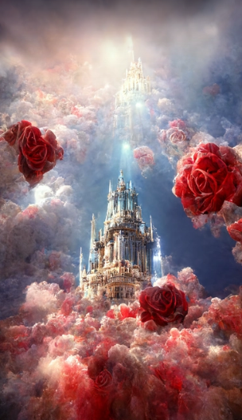

<https://i.mj.run/59bc59e5-f9ea-4afc-9ed5-2c72d9dd7e89/0_0.png> Gorgeous crystal palace, CG rendering European style, overlooking, fairy tale, rose surround, lighting effect, dream, starry sky, super detail, illustration, 4K, unreal engine, ethereal cloud, HD, --ar  9:16

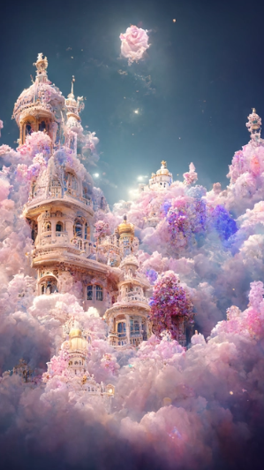

A hyperreal photo of Milky Way and the moon, the glowing quicksand flowing from the moon,blue fluorescent sea, red roses floating on the water,uplight, 4K, unreal engine, octane render --ar 9:16 --q 2 --uplight

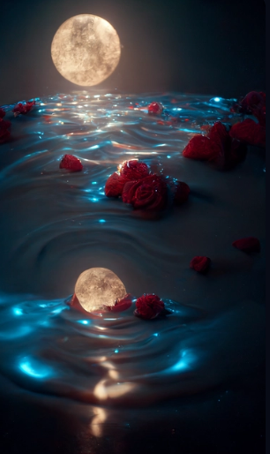

Morning, sunrise, sunshine, dream castles, Butterflies, fog,waterfalls, clouds, lots of little roses, above+super wide Angle, Thomas Kinkade,Trending on artstation - Upscaled by,iceberg,fantasy,high detail,beauty,8K,octane shading,complex details,ultra wide angle of view, panoramic shooting,8K.HD --ar 9:16

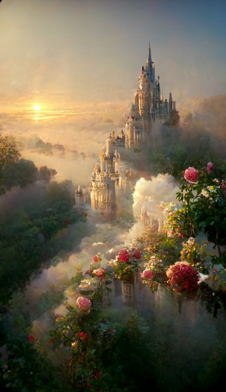

**Romantic blue ocean, sparkling snow beach, rose crystal, Milky Way, a shooting star, shining many tiny creatures, pink yellow rose crystal, Arctic, tundra, iceberg, fantasy, highly detailed, 8k, octane number rendering, lifelike, complex details, super wide viewing angle, panoramic lens, volume light. --ar 9:16

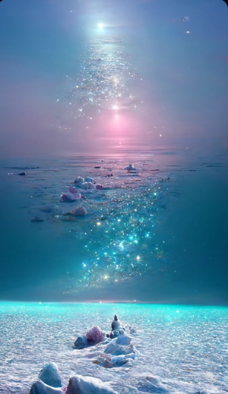

<https://i.mj.run/81e65175-f0db-40fd-b251-e53f89ee2d56/0_0.png> pink and red rose dripping in gold and diamods,photo realistic, ar 9:16, dramatic lighting, octane render, ultra detail --test --creative --upbeta

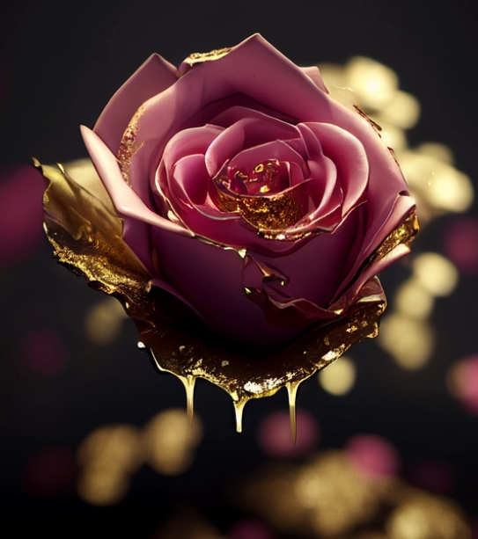

<https://i.mj.run/4d939d4f-9b76-4ace-b486-9ab0a4531238/0_2.png> One kind of flower is pink, its petals are transparent, deep as sea water, crystal like dew, it can feel the loyalty and purity of love, Gorgeous crystal shop white church, red rose, lighting effect, romance, CG rendering European style, overlooking, fairy tale, rose surround, lighting effect, party, super detail, 8K, unreal engine, unreal cloud, HD --ar 9:16

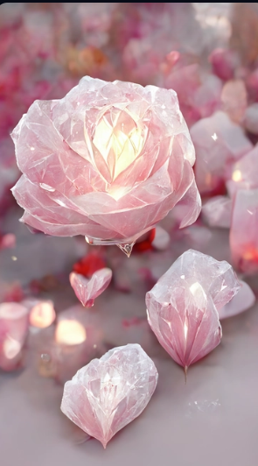

The picture is transparent, a large silvery white crescent is sprinkled on the sand accompanied by the Milky Way stars, there are many pink and blue roses floating on the sand, pink and blue roses floating on the sea, a beach in the shape of a heart, glowing creatures, Silver, Unreal Engine, Ultra Wide, 4K HD, --ar 9:16

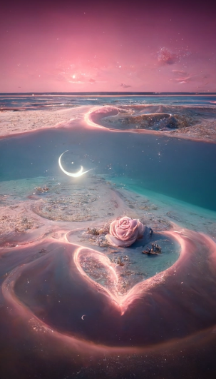

The blue ocean, the white snow beach, the freezing, the milky way shining with roses all over the ground, there are many luminous creatures on the beach, the beach is in the shape of love, pebbles, luminous creatures, fluorescent, golden, colorful, dreamy, super wide-angle light halien unreal engine, 8k, octane rendering, photo-realistic and intricate details, super wide viewing angle, panoramic shooting, 8k --ar 9:16

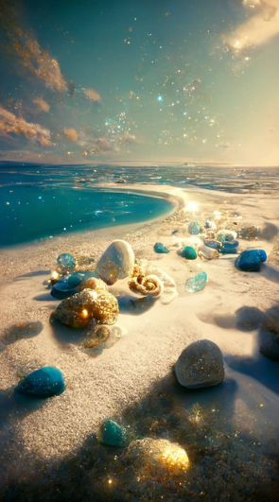

<https://s.mj.run/FthMmTqo_jw> A real photographic landscape painting,Ultrawide view,On sea surface,Red rose,Fire flowers,Morning,Volumetric lighting,Clearing,Unity,Fitz henry lane,artstation --ar 9:16

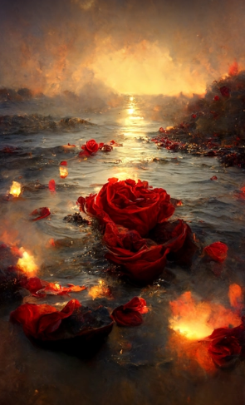

<https://i.mj.run/78e6fe23-1e26-4525-86fe-46222ea327d0/0_0.png> Under the night sky, the beach is covered with a large number of red crystal roses (16K), dark blue fairy roses, crescent moon, lights, fluorescent sea, moonlight on twinkling stars, Michael James Smith's matte painting, reflection, CG social selection, volume light, space art, bioluminescence, phosphor, unreal engine 5, magic of light, rendering in unreal engine, ultra wide angle of view, ultra wide angle of view, 16K HD picture HD --ar 9:16

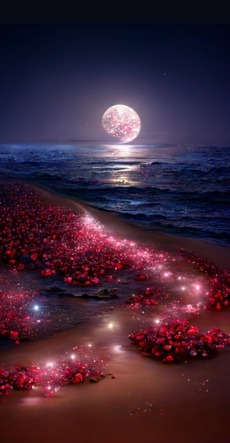

A white smoky rose is in the middle of the screen, super light pink rose, tender pink rose, white fold background, empty loneliness, lonely and lonely atmosphere, dream, soft light, white starlight surround, super detail, super detail, HD, 8K, 3D, high-definition picture, hyperrealistic style --ar 9:16 --uplight

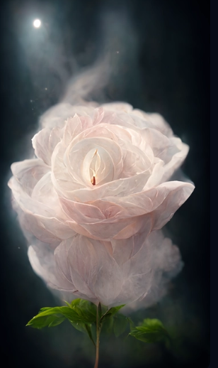

<https://i.mj.run/d4dc6f75-db75-47c9-8a30-e0c8a78ff8ed/0_0.png> Light purple sea, white snow beach, freezing, many tiny and colorful yellow rose crystals shining in the Milky Way, snowflakes in the sky, Arctic, tundra, icebergs, fantasy, highly detailed, beautiful, 8k, octane rendering, photorealistic, intricate details, A wall of crystals，super wide viewing angle, panoramic shooting, 8k --ar 9:16

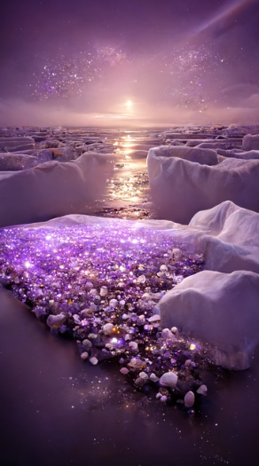

<https://s.mj.run/oey3SQ98V7U> this is surreal and exquisite CG rendering. Atnight, the pale blue sky, glaciers covering the beach,purple heart-shaped stones, glowing paths, roses, themoon, starlight, art, high definition, starry sky, manytiny and colorful luminous particles, illuminated by theMilky Way, the Arctic, tundra and icebergs, fantasy,high details, beauty, 8K, octane light and shadow,complicated details, super wide angle, panoramicshooting, 8k. High definition.Volumetric light，8K HD --ar 9:16

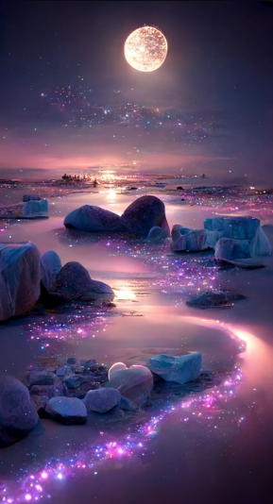

A dazzling Chinese palace, connected by bright roads, Chinese dragons and Phoenix in the sky, 14K CG rendering Chinese style, fairy tales, surrounded by white roses, lighting effects, fantasy, starry sky, super details, illustrations, ultra- high resolution, 4K, illusory engine, clouds .HD --ar 9:16 --q 2

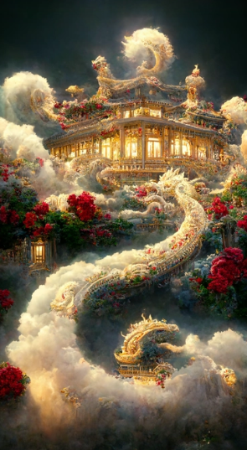

Extravisible Subdimensional Roses, recursionpunk, fractalcore, Ultra HD, ISO, f, Kodak, Canon, 8k --testp --ar 2:3 --s 5000 --upbeta

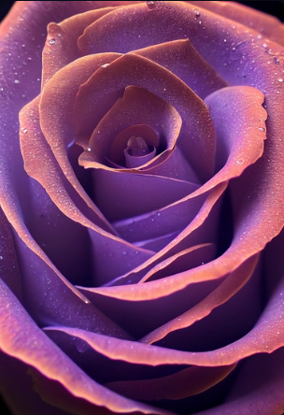

<https://i.mj.run/dee9d163-f965-4a0e-bbeb-452bbf3a092b/0_3.png> Blue ocean, shimmering these stars, white snow color transparent ice cubes with roses, frozen frozen, fell in the sea and snow moon reflected in the Milky Way, the arctic, tundra, glacier, at dusk, fantasy, highly detailed, beautiful, 8 k, octane render, lifelike, the details of the complex, super wide viewing Angle, 8k --ar 9:16

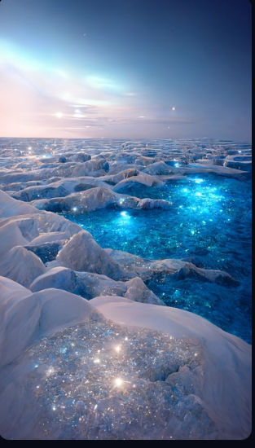

There is a kind of flower that is white. Its petals are as deep as sea water, and its heart is like dew. There are many green leaves on the branches, and many crystal white button chrysanthemums. You can feel its loyalty and purity in comparison with love.HD --ar 9:16

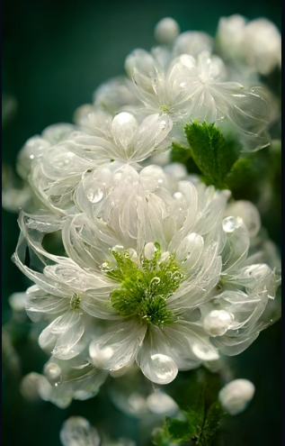

Sky reflected in still water, rainbow, sun, sunset, Nikon camera photography --ar 9:16

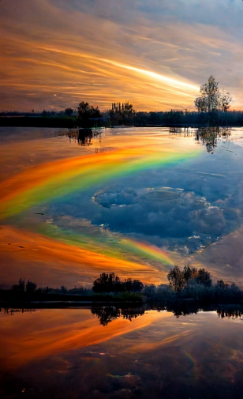

Sky reflected in still water, rainbow, sun, sunset, sunset, clouds, Nikon camera photography --ar 9:16

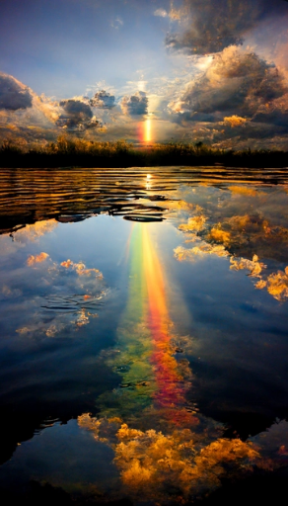

Night sky, The stars shine on the silky lake , Aurora, Elf light, Stars, The stars are twinkling , The wide lake, Starry sky, Matte painting by Michael James Smith, CG rendering, Volume light, Space art, Bioluminescence, Unreal Engine 5, Ultra-wide angle, High definition ,HD --ar 9:16

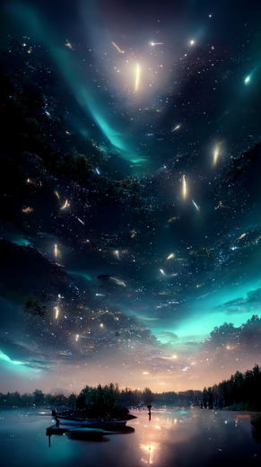

Night sky, The stars shine on the silky lake , Aurora, Elf light, Stars, The stars are twinkling , The wide lake, Starry sky, Matte painting by Michael James Smith, CG rendering, Volume light, Space art, Bioluminescence, Unreal Engine 5, Ultra-wide angle, High definition ,HD --ar 9:16

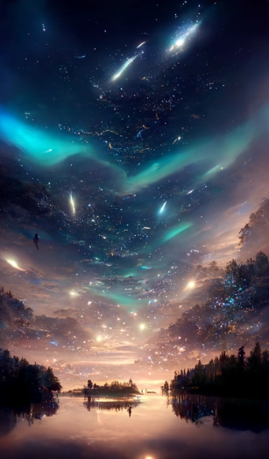

Night sky, The stars shine on the silky lake , Pink aurora, Elf light, Stars, The stars are twinkling , The wide lake, Starry sky, Matte painting by Michael James Smith, CG rendering, Volume light, Space art, Bioluminescence, Unreal Engine 5, Ultra-wide angle, High definition ,HD --ar 9:16

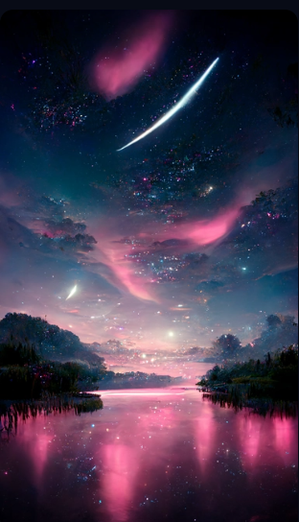

<https://i.mj.run/b493ebe0-0e59-4802-9397-4e87ab21c910/0_0.png> Pixar style, girl sitting at a mystical pond, aurora borealis, glowing insects flying around, photorealistic, intricate detailed, Disney Pixar concept art, 8K —ar 2:3 --test --creative --upbeta

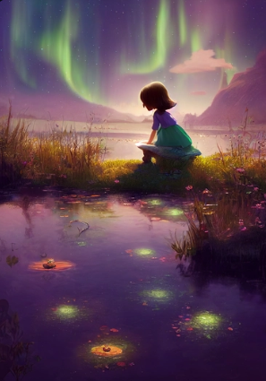

Pixar Style, Tiny cute baby fall bear adventurer dressed in hat, jean - baptiste monge , anthropomorphic , dramatic lighting, 8k, portrait --testp --ar 2:4 --upbeta --upbeta

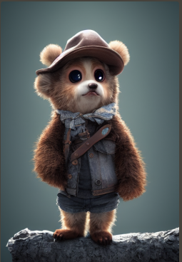

<https://i.mj.run/5ef66915-aa85-4739-9d3e-6b44328f1262/0_0.png> Personified Majestic Cat Knight, white cat, turquoise blue eyes, noble, portrait, elaborate armor, movie lighting, intricate filigre-metal design,4K,8K, Unreal engine, octane rendering, HD --ar 9:16 --testp --upbeta

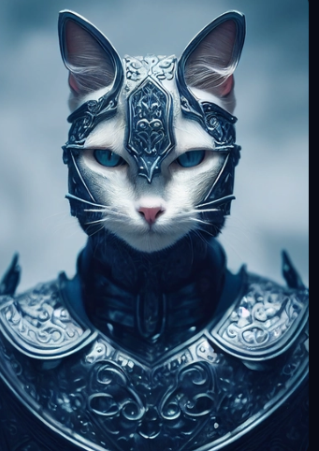

Anthropomorphic majestic white tiger knight, portrait, finely detailed armor, cinematic lighting, intricate filigree metal design, 4k, 8k, unreal engine, octane render --ar 9:16 --testp --upbeta --upbeta --upbeta --upbeta

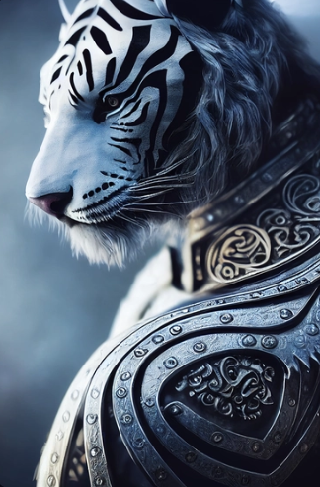

Personified Majestic Cat Knight, white tiger, turquoise blue eyes, noble, portrait, elaborate armor, movie lighting, intricate filigre-metal design,4K,8K, Unreal engine, octane rendering, HD --ar 9:16 --testp --upbeta --upbeta

